AN ABSTRACT OF THE THESIS OF

Allison Swartz for the degree of Master of Science in Forest Ecosystems and Society presented on June 6, 2019.

Title: Stream Temperature and Periphyton Responses to Riparian Canopy Gaps Over Forested Headwater Streams in the Western Cascade Mountains of Oregon

Abstract approved: ______________________________________________________

Dana R. Warren

Across much of North America, legacies of historic timber management and ongoing timber harvest have created a landscape dominated by second-growth forest stands in the early to middle stages of development. Most streamside forests are currently in the stem-exclusion phase of stand development and these closed canopies shade the forest understory and reduce light flux to streams. However, this highly-shaded environment in second-growth forest streams contrasts with those in old-growth forests, which contain spatially dynamic and temporally complex light conditions created by canopy gaps. Gaps in the riparian canopy that increase local light availability can enhance primary production in streams, which can propagate up the food web leading to increased fish abundances. Although increasing light availability to streams can enhance bottom-up drivers of invertebrate, fish and salamander in streams, this can also increase stream temperature, which can be detrimental if temperatures increase too much and many current riparian forest management regulations focus on maintaining cool temperatures. Therefore, knowing whether and to what degree opening riparian canopies through gap creation (via natural or anthropogenic processes that increase light exposure to forested streams) leads a change in temperature has important ecological and management implications. To determine the impacts of riparian canopy gaps with subsequent localized increases in light on stream temperature and on stream biofilms we created experimental gaps in second-growth riparian forest canopies. Using a Before-After-Control-Impact design, we analyzed the following stream summer temperature metrics: the maximum seven day moving average maximum, the maximum seven day moving average mean, daily maximum and daily mean summer temperature responses. We also quantified changes in light and reach scale chlorophyll *a* at finer spatial scales following the implementation of riparian canopy gaps in six heavily shaded headwater streams with second-growth stands regenerating from forest harvest. We observed small but consistent increases in temperature due to the gap treatment and also increases in chlorophyll *a*. In addition to considerations regarding forest management, understanding temperature and aquatic ecosystem responses to riparian canopy gaps is critical to predicting stream responses to natural disturbances and stand development in unmanaged forests recovering from past use.

©Copyright by Allison Swartz

June 6, 2019

All Rights Reserved

Stream Temperature and Periphyton Responses to Riparian Canopy Gaps Over Headwater Streams within Second-Growth Forests in the Western Cascades of Oregon

by

Allison Swartz

A THESIS

submitted to

Oregon State University

in partial fulfillment of

the requirements for the

degree of

Master of Science

Presented June 6, 2019

Commencement June 2019

Master of Science thesis of Allison Swartz presented on June 6, 2019.

APPROVED:

_____________________________________________________________________

Co-Major Professor, representing Forest Ecosystems and Society

_____________________________________________________________________

Head of the Department of Forest Ecosystems and Society

_____________________________________________________________________

Dean of the Graduate School

I understand that my thesis will become part of the permanent collection of Oregon State University libraries. My signature below authorizes release of my thesis to any reader upon request.

_____________________________________________________________________

Allison Swartz, Author

ACKNOWLEDGEMENTS

I would like to thank Dana Warren for his continued support, guidance, mentorship, and positive attitude throughout my experience in graduate school.

I would also like to thank Steven Perakis, Maryanne Reiter, and Matthew Powers for their support and feedback and help in the field.

I would also like to thank Mark Schulze, Greg Downing, Jay Sexton, as well as the staff and community of the HJ Andrews. Greg and Jay performed the cutting treatments and this project would not have been possible without them.

I would like to thank Emily Heaston, Dave Roon, Matt Kaylor and Sami Cargill for being awesome lab-mates.

I would like to thank Cedar Mackaness for helping collect these data and being an awesome field technician.

I would like to thank Alvaro Cortes, Brain VerWey, Brook Mackaness, Nate Day, Corey Culp for their hard work and positive attitudes in the field.

I would also like to thank Karla Jarecke and Evan Thaler for their help, support and encouragement.

Finally, I’d like to thank my family, Logan, Karen and Barry Swartz for their constant encouragement and support.

Funding was provided by the HJ Andrews LTER, the Fish and Wildlife Habitat in Managed Forests Grant Program, and the College of Forestry at Oregon State University.

TABLE OF CONTENTS

Chapter 1. Chapter 1: Stream Temperature responses to riparian canopy gaps 1

Introduction 1

Methods 5

Study design and locaiton 5

Canopy treatment 6

Data Collection 7

Statistical Analysis 11

Results 13

Gaps, shading and light responses 13

Summer temperature (T7DayMax, T7DayMean, maximum daily maximum, average daily mean, regressions of daily maximums and daily means) 14

Explanatory Variables 16

Discussion 16

Conclusion 25

References 26

Figures 30

References 37

Chapter 2: Influence of riparian canopy gaps on in-stream periphyton 39

Introduction 39

Methods 42

Spatial Light 42

Chlorophyll *a* 42

Data analysis 43

Results 43

Light 43

Chlorophyll *a* 44

Discussion 45

Conclusion 48

References 49

Figures 52

Appendix 59

LIST OF FIGURES

Figure 1.1: Map of study site locations 29

Figure 1.2: Temperature logger locations 30

Figure 1.3: Reach differences by year of shade and light 31

Figure 1.4: Maximum 7 day moving average maximum temperatures 32

Figure 1.5: Maximum daily temperature yearly regressions 33

Figure 1.6: Longitudinal temperatures 34

Figure 1.7: Explanatory variables of the maximum 7 day moving average temperature response. 35

Figure 2.1: Spatial daily PAR 51

Figure 2.2: Reach avearges of daily PAR 52

Figure 2.3: Spatial chlorophyll *a* 53

Figure 2.4: Reach averages of chlorophyll *a* 54

Figure 2.5: Explanatory variables of chlorophyll *a* responses 53

LIST OF TABLES

Table 1.1: Site description details for the six streams 41

Table 1.2: Overall temperature responses for six metrics across all the stream sites 42

LIST OF APPENDICES

Figure A.1: T7DayMean values 59

Figure A.2: Daily mean yearly regressions 60

Table A.3: BACI Statistical Analyses for T7DayMax and T7DayMean values 61

Table A.4: BACI Statistical Analyses for daily maximums and daily minimums 61

Table A.5: Regression estimates for each site before and after the cut 62

Table A.6: Fitted estimates for explanatory variables 62

Table A.7: BACI Statistical Analyses for mean PAR and mean chlorophyll *a* 62

Chapter 1: Stream Temperature responses to riparian canopy gaps

Introduction

Across much of North America, legacies of historic timber management and ongoing timber harvest have created a landscape dominated by second growth forest stands in the early to middle stages of development (Pan et al. 2011). Past land clearing has encompassed both upland and streamside (riparian) areas, and while contemporary management regulations commonly restrict clearing the riparian zone (Lorensen et al. 1994), most streamside forests are currently in the stem-exclusion phase of stand development (Franklin et al. 2002). The closed canopies, characteristic of these second growth stands, shade the forest understory and reduce light flux to streams (Kaylor et al. 2016). However, this highly-shaded environment in second growth forests contrasts with old-growth forests, which contain spatially dynamic and temporally complex light conditions created by canopy gaps (Canham et al. 1990). If left unmanaged, riparian forest buffer zones will naturally progress toward later developmental stages when gaps become common over long timescales. In the interim, short-term active management practices to implement canopy gaps may help promote the restoration of old-growth forest structure and enhance stand complexity. Gaps in the riparian canopy that increase local light availability to streams can enhance primary production in streams, which can propagate up the food web and has been linked to greater fish biomass (Kaylor et al. 2016). However, opening riparian canopies through gap creation via natural or anthropogenic processes that increase light exposure to forested streams, can also increase stream temperatures, which contrasts with a key objective of many current riparian forest management regulations. The goal of this study was to determine how experimental canopy gaps in the riparian zone affect stream temperature in fish-bearing headwater streams in the western Cascade Mountains of Oregon.

Thermal conditions are fundamental regulators of ecological processes and biota in streams (Magnuson et al. 1979, Beschta et al. 1987, Poole and Berman 2001, Moore et al. 2005b, Caissie 2006). Increases in temperature may be considered beneficial for a system because they can accelerate rates of photosynthesis and autotrophic growth as well as ecosystem respiration (Acuna et al. 2008, Demars et al. 2011, Hill et al. 2014). Similarly, for many ectothermic organisms, growth rates increase with temperature up to a point (assuming adequate food resources), so an increase in temperature may increase growth. However, once a threshold is exceeded, further increases in temperature can be highly detrimental to a system with declines in production, condition, and ultimately survival (Sloat et al. 2005, Bear et al. 2007). Historic forest management practices that removed all riparian vegetation led to large increases in temperature in many systems, and the negative impacts of the resulting high temperatures on aquatic biota – particularly salmonid fishes – have motivated forest management regulations that focus on streams (McCullough et al. 2001). Short-wave solar radiation is a dominant component of the stream heat budget (Poole and Berman 2001, Moore and Wondzell 2005, Caissie 2006), and past removal of streamside forests exposed many headwater streams to high light conditions. As a result stream temperatures increased in many cases, to levels detrimental to aquatic biota (Brown and Krygier 1970, Beschta et al. 1987, Sinokrot and Stefan 1993, Johnson 2004, Moore and Wondzell 2005). For this reason, current forest management regulations that restrict harvest of riparian forests often focus on maintaining unmanaged riparian buffers to support highly shaded streams and minimizing solar radiation to limit increases in stream temperature (e.g. Oregon Forest Practices Act) (Lorensen et al. 1994, Johnson and Jones 2000, Poole and Berman 2001, Moore et al. 2005a, Groom et al. 2011b).

Shading is important to keep streams cool, however, as stands and buffers have regenerated, stream light has fallen below historic levels found in many old growth systems (Kaylor et al. 2016). Gap development is a dominant process at the horizontal diversification stage of stand development (Franklin et al. 2002). Compared to larger disturbances such as large harvests and fires, these smaller events may be more frequent, giving them the potential to impact a larger area over time (Spies et al. 1990). Also, as the sun angle changes throughout the day, the effect of a gaps on light may be much larger than the canopy opening itself as understory light extends beyond the gap (Heaston et al. 2017), and at relatively high latitudes such as in the Pacific Northwest the change in sun angle over the course of the summer also increases the overall area of elevated light due to the gap (Canham et al. 1990). In Douglas-fir forests, gaps occur as a result of tree mortality or crown loss from a range of factors including wind-throw, diseases such as laminated root rot (*Phellinus weirii*) and velvet top Fungus (*Phaeolus schweinitzii*), and insects, especially the Douglas-fir bark beetle (*Dendroctonus pseudotsugae* Hopkins). Gaps vary in size as a result of the different mortality events and are a result of the size of present trees themselves. Gap sizes are therefore often measured in terms of the ratio between gap diameter and average tree height. Smaller gaps generally occur more frequently but across old-growth stands with highly variable tree heights gap diameter to height ratios are also quite variable (Spies et al. 1990, Gray and Spies 1996). In the Pacific Northwest, gap sizes from individual tree mortality events commonly vary from 0.05 to 0.4.

Increasing the spatial heterogeneity of light created by gaps in the riparian canopy may have the potential to increase the abundance of stream biota by alleviating light limitation and promoting primary production in localized patches (Kaylor and Warren 2017, Heaston et al. 2018). The changes in primary production that occur beneath canopy gaps may be effective even at small spatial scales because benthic biofilms – dominated by algae – are disproportionately important as a food resource at the base of stream food webs (Thorp and Delong 2002, McCutchan et al. 2003, Cross et al. 2005). And beyond the stream, canopy gaps can increase spatial heterogeneity of forest structure, which can benefit wildlife, and can release remaining trees from competition, allowing them to grow larger faster. Many studies have suggested that buffers should reflect natural disturbance regimes that promote forest structural complexity (Kreutzweiser et al. 2012, Moore and Richardson 2012, Sibley et al. 2012). But, sunlight (short-wave radiation) is a key component of the stream heat budget, and even small-scale increases in light have the potential to affect the temperature of headwater streams (Janisch et al. 2012). Therefore, whether stream temperature increases as a result of a gap or as a result of other processes that create moderate increases in light (e.g. narrow riparian buffers, defoliation events, low-severity burns etc.) remains a key question in forest management for restoration and for understanding of how temperatures may change as stands develop over time. Whether to understand naturally developing gaps or to evaluate gaps as a potential management tool that emulates localized disturbances and restores heterogeneity in stream light, few experiments have explicitly assessed the impacts of forest gaps on streams.

To determine the impacts of riparian forest canopy gaps and the associated localized increases of light on stream temperature, we created experimental gaps along six replicate headwater streams within second growth riparian forests. Comparing temperature in treatment reaches to those in reference reaches, we used a Before-After-Control-Impact study design to analyze summer stream temperature responses to riparian canopy gap creation. In addition to quantifying local temperature responses (e.g. beneath gaps), we also evaluated whether and to what degree effects persisted downstream, and we evaluated how gap and stream features affected potential stream warming. The size of gaps created in this study mimicked gaps created by a relatively small scale natural disturbance such as a multiple tree mortality or wind throw event. We expected these small gaps to increase temperature locally, but that impacts would be small (less than 1oC) and would dissipate rapidly downstream of the gap location.

Methods

*Study design and location*

This study took place in six streams located within the McKenzie River Basin in the western Cascade Mountains of Oregon. Each stream consisted of two paired reaches (a reference reach and a gap-creation treatment reach). Three of the reach pairs are located on private land owned by Weyerhaeuser Co. (W-113, W-100, and W-122) and three are on US Forest Service (USFS) land in the Willamette National Forest (McTE, Loon Creek and Chucksney Mountain Creek). One of the USFS sites (McTE) is located within the HJ Andrews Experimental Forest. The western Cascade Mountains of Oregon are characterized by a Mediterranean climate with high precipitation during winter months and low precipitation during summer months. Data for this study were collected during the summer (July through September) of 2016-2018 for the USFS sites McTE and Chucksney, and the summer months of 2017 and 2018 for the remaining sites. We used a Before-After-Control-Impact (BACI) study design with a set of paired reference and treatment (impact) study reaches in each of the six replicate streams. Gaps were created in treatment reaches between late fall 2017 (after leaf fall) and early spring of 2018 (before leaf-out), with the exception of McTE where the gap was cut at in August of 2017.

The study systems are second- and third-order fish bearing headwater streams within 40 to 60 year-old mid-seral riparian forests (Table 1.1). Each site’s previous harvest left no riparian buffer along the stream. All sites had closed overstory canopies with tree communities that were composed predominantly of red alder (*Alnus rubra*) and Douglas fir (*Pseudotsuga menziesii*) with sporadic western red cedar (*Thuja plicata*); the Weyerhaeuser Co. sites also contained bigleaf maple (*Acer macrophyllum*). Stream bankfull widths ranged from 2.2 to 6.4 meters (Table 1.1).

Study sites in each stream encompassed two 90 to 120 meter reaches, plus a buffer section of 30-150 meters between reaches. We excluded sites that had large tributary inputs within or between the study reaches. At four of the six stream sites, we applied the experimental canopy modification to the downstream reach. Due to concerns about slope stability in the mid-sections of the downstream reaches, the treatments were applied to the upstream sites at Chucksney Mountain Creek (hereafter “Chucksney”) and W-122. At Chucksney and W-122, the buffer sections are over 100 meters long to establish independence between reaches. The paired reaches (one reference and one treatment) allow for analyses to be conducted on the relative differences between reach pairs. By using a BACI design we can compare reach differences between the pre and post years to reduce inherent stream-to-stream environmental variability (e.g. gradient, geology, substrate etc) as well as natural variation between pre and post treatment summers.

*Canopy treatment*

In each treatment reach, we planned for gaps that would create openings in the canopy that were approximately 20 meters in diameter over the stream. We assumed an average site potential tree height of 50 meters, and in seeking to create a gap with a ratio of approximately 0.4, we laid out cuts for an intend gap diameters of 20 meters (approximately 314 square meters). Gaps were positioned to surround approximately meter 30 of each treatment reach. Because gaps were cut in winter when deciduous trees had no leaves and due to vagrancies of tree fall as well as safety considerations when trees hung up in felling, the actual gap sizes varied sites from approximately 514 to 1,374 square meters. This range in gap sizes includes openings created by small-scale disturbances that kill more than an individual tree as initially intended, however, even the largest gap in this study is still small when considering the full range of natural gaps that occur in late successions forests (Gray and Spies 1996), and overall, the gaps sizes here are representative of openings that still occur, but relatively less frequently than smaller gaps, from natural disturbances in late-successional forests.

*Data Collection*

Three to five hemispherical canopy photographs were taken along each reach at 30-meter intervals. The site of each picture location was noted in the pre-treatment years and the height of the camera for each photograph was recorded for each location. The post-treatment photographs were then taken in the same location with the camera at the same height in summer 2018, after the gaps were cut. Photographs were taken during either dawn or late dusk to avoid direct sun. Changes in effective shade were quantified using the global site factor (GSF) calculated in HemiView™ 2.1 software (Delta-T Devices, Cambridge, UK). GSF is the proportion of direct plus diffuse radiation under the canopy relative to that radiation at the given location (latitude and longitude) out in the open. All photograph variables were averaged for each reach. Forest fire prevented us from accessing Loon and Chucksney in the Post year during the time scheduled for photographs based on the time of the summer they were taken in the pre-treatment year.

Light was measured by quantifying the 24 hour photodegradation of fluorescein dye in vials deployed at 5 meter intervals along the stream bed. Following methods in (Bechtold et al. 2012, Warren et al. 2013, Kaylor et al. 2016), an array of three vials were filled with fluorescein dye (batch concentration of approximately 400 ppm Turner Designs, Sunnyvale, CA) and were left for 24 hours and then fluorescein vials were collected and concentrations were re-measured. The change in concentrations correlates with the daily amount of light exposure at each location (Warren et al. 2017). Every fifth array contained a “control” vial that was wrapped in aluminum foil, which prevented any photodegradation and therefore served as a “field blank” that could be used to account for any background drift in fluorescein concentration. All vails were stored in the dark for at least 4 hours and brought to room temperature before measurements were taken with a Turner Designs AquaFluor handheld fluorometer. Values from each 5 meter interval along a given reach were then averaged to obtain a mean fluorescein decay per reach. Fluorescein decay was converted to daily PAR using the relationship established in Warren et al. (2017) on sites in the HJ Andrews Experimental Forest.

Five temperature data loggers were stationed in the thalweg of each reach at meters 0, 30, 60, 90, and 120 (Figure 1.2). Continuous temperature data were recorded at 15-minute intervals using Onset TidbiT water temperature data loggers (Onset HOBO model UTBI-001, accuracy ±0.21 °C accuracy) and ﻿HOBO Water Temp Pro data loggers (Onset HOBO model H20-001, ±0.2 °C accuracy). Prior to deployment, loggers were validated against one another in a well-mixed ice bath for 1 hour recording every 15 seconds while allowing ice to melt and temperatures to warm. Loggers out of the range of accuracy specified by the manufacturer were replaced. Loggers were deployed mid-July and retrieved in early September. During electro-fishing sampling events, loggers were removed from the water. To avoid skewing daily values, the entire day of data during these events were removed. Temperature loggers were housed in white PVC piping with holes and placed parallel to flow to prevent the influence of direct solar radiation and allow for adequate flow through the piping.

Numerous metrics that can be extracted from long-term temperature data (Arismendi et al. 2013). In quantifying the responses of stream temperatures to riparian canopy gaps, we focused on four key metrics that are commonly evaluated in other studies, and which apply most directly to management regulations. We first used the 15-min data to calculate daily mean and daily maximum temperature values for each logger location over the same day of year period of record for each logger before and after the gaps were cut. We performed our analysis of daily temperature through a 40-day period (from July 22 to August 31) where we have consistent data at all locations, and which encompasses the time of maximum temperature values in streams of this region. Mean and maximum daily temperature are frequently used in stream water quality assessment (Groom et al. 2011a, Arismendi et al. 2013). These metrics and the 40-day time period align with other published studies, in particular work by Groom et al. to evaluate stream temperature changes in a riparian buffer experiment (2011a).

At streams Chucksney and McTE, data from 2016 were used for pre-treatment data. We used 2016 data from Chucksney because a forest fire near this site at the end of summer 2017 closed access until December 2017 (at which point high flows as washed the logger away). At McTE, the gap was cut in mid-August of 2017 and we therefore did not have a full summer of pre-treatment temperature data for 2017 at this site. Both reference and treatment sites at these two streams were instrumented with the Hobo loggers in 2016 during project planning. Pre-treatment data for the remaining sites are from 2017. By using a BACI study design and focusing on changes in the differences between reaches before versus after the cuts, we account to a large degree for use of pre-treatment data from different years at these sites because it evaluates differences between sites within a year, before considering the changes between years due to the experiment.

Stream temperature can vary a great deal over 40 days, so to focus in on the maximum potential effect of the treatments on stream temperature in mid-summer, we also calculated 7-day moving averages of mean and maximum daily stream temperatures. These two metrics, maximum 7-day moving average means (T7DayMean) and maximum 7-day moving average maximums (T7DayMax), reflect the week in each summer at each location when mean and maximum stream temperatures over that week were greatest without being too heavily weighted by one day. As with the mean daily temperature and the maximum daily temperatures, the maximum 7 day moving average maximum (T7DayMax) also aligns with many regulatory criteria. The T7DayMax is recommended by the USEPA as a descriptive metric for temperature as it is not overly sensitive to values on a single day (McCullough et al. 2001). In Oregon, the Protecting Cold Water (PCW) criterion prohibits warming of existing cold waters from anthropogenic increases by prohibiting an increase of more than 0.3oC in the T7DayMax and the regulatory standards for the T7DayMax are 16 °C for core cold-water fish rearing habitat, 18 °C for non-core juvenile rearing and migration, and 20 °C for migration of salmon and trout (USEPA 2003).

In order to evaluate potential changes in the overall trend in temperatures across an entire summer season, we used a regression approach to compare relationships between reaches during each year. This approach treats the reference reach as the independent variable and the treatment reach as the dependent variable and has been used in multiple other temperature assessment studies to capture processes occurring over a summer season – rather than compressing data to a single value (Groom et al. 2011a, Kibler et al. 2013, Bladon et al. 2016). In each year – pre and post gap treatment - the regressions evaluated the relationship between daily temperature (maximum and mean) in the reference reach and daily temperature in the treatment reach. The slope of the relationship in the pre-treatment year relationship is assumed to reflect the ambient relationship between reaches and accounts for any warming or cooling that may occur naturally as water moves from one reach to another in these systems. Differences in the slope of the relationship between the pre and post-treatment years are attributed to the gap treatment.

In addition to evaluating temperature responses at the downstream end of each reach we also quantified temperature responses longitudinally in each study reach. We placed loggers every 30 meters along each reach (Figure 1.2) between 0 and 120m. In Chucksney and McTE in we only had data from meters 0 and 90 in the pre-treatment year. In W-113, the logger at distance interval 60 of the reference reach failed in the pre-treatment year. For longitudinal profiles of stream temperature, we focused on the T7DayMax temperature metric along each reach before and after gaps were cut over a portion of the study area. The T7DayMax is characterizing responses during the hottest week in each year and therefore the results of this analysis represent a picture of the largest potential responses observed.

*Statistical Analysis*

In order to identify the effects of the gap on stream shading and stream light as well as T7DayMax and T7DayMean, we fit a linear mixed-effects model fit by REML using the nlme package ﻿(Pinheiro et al., 2016) in R (R Core Team, 2014) to the data. The response variable, Tt, is the observed PAR value for that reach. The same model was applied to detect responses in daily maximum, daily mean, T7DayMax and T7DayMean. The fixed effects included Year (Pre or Post), Reach (Reference or Treatment), and the BACI effect, which is the interaction term of Year and Reach identifying the effect of the imposed gap. Additionally, random effects for Stream and Reach were included as nested random effects and the assumption of constant variance was relaxed.

Tt = Year + Reach + BACI + (1|~Stream/Reach) + εt

Where εt is the random effect term for the *tth* group, where εt ~ N(0, σε2) and εt and εt’ are independent.

To assess changes in daily maximum and daily mean temperatures due to the gap, we applied the same model as above, however due to the repeated (daily) measurements over the 40 day period, we also tested for temporal autocorrelation. We tested four correlation structures and chose the best model based on the lowest AIC value, and therefore included the corCAR1 term to account for autocorrelation. To visualize and identify the effect of the gap on maximum daily temperature we correlated the reference and treatment reaches against each other for both years.

Finally, to better understand which features best explain the variability in temperature changes across the six study sites, we explored how stream and gap characteristics related to the stream temperature responses in T7DayMax across sites. We focused on responses, defined here as the change in the reach difference, of T7DayMax because of the metric’s biological and regulatory relevance, as noted above. We regressed T7DayMax responses against four explanatory variables: light exposure (mid-summer daily PAR) response, gap area, baseflow discharge, and bankfull width. These metrics relate to one of two overarching drivers: solar exposure or thermal mass, and the regressions functionally address the question of whether the changes in temperature that we see in response to the treatment are best explained by factors relating to gap size and light or whether they are more closely related to underlying stream characteristics for the range of stream and gap sizes evaluated here. Changing light exposure is the key mechanistic process that is expected to be related to a response in temperature because solar radiation is a principal factor for stream temperature (Brown and Krygier 1970, Sinokrot and Stefan 1993, Johnson 2004). Therefore, measuring the relationship with a measure of light exposure is important, however this is not a metric that is commonly included in stream assessments. Stream gaps size can be evaluated more easily by managers and practitioners in the field or even remotely via LiDAR if those data are available. Similarly, we consider both stream baseflow (mid-summer) discharge measured using salt releases at all six sites within a one-week period at the end of July, and the mean bankfull width of each stream in the regression analysis. Discharge describes the volume of water moving through the stream and is therefore fundamental in characterizing the thermal mass of water. However, it is less common to quantify discharge in rapid assessments and stream discharge can change over time. Conversely, stream bankfull width is easy to measure, and within a region is a useful and consistent measure of relative stream size. An assessment of light and discharge are expected to align more closely with the mechanisms that account for a change in stream temperature, while an assessment of the gap size and stream bankfull width are expect to reflect these mechanistic processes in two metrics that are seasonally integrated and more easily assessed.

Results

*Gap, shading and light*

Across the six sites mean gap size was 962 m2 (0.096 hectares) with a standard deviation of 316 m2, and individual gaps ranged in size from 514 m2 to 1,374 m2 (0.051 to 0.137 hectares) (Table 1.1). Mean stream shading as effective shade from the hemi-photograph analysis was 90.3% across all reaches prior to the gap treatment (mean of 90.5% in reference reaches and 90.2% in treatment reaches). After the gap treatment the reference reaches remained about 90% shaded (90.02%) while the treatment reach mean shading declined by approxiamtely 4% to (86.7%) shaded throughout each reach (Figure 1.3). Light exposure responses, as expected, increased after the canopy gaps. In the pre-treatment period, mean difference in light between reference and treatment reaches was -0.10 moles m-2 day-1. After gaps were cut, the mean difference in light between reaches increased significantly (p < 0.001) to a mean of 3.91 moles m-2 day-1 resulting in a mean change in light of 2.93 moles m-2 day-1 overall. Considering sites separately, McTE had the largest gap, which lead to the largest decrease in shade and correspondingly the largest increase in light, and similarly, W-113 had the smallest decrease in shade and the smallest increase in light (Table 1.1, Figure 1.3).

*Summer temperature (T7DayMax, T7DayMean, daily maximums, daily means, regressions of daily maximums and daily means)*

Overall, the gap treatments did not change summer T7DayMax or T7DayMean significantly across the 6 study sites (Figure 1.4, Table 1.2). The mean response (change in reach difference before and after the cut) across the six sites in T7DayMax was 0.21oC and in the T7DayMean was 0.15oC. The overall average responses across the six sites for average daily maximum and average daily means were 0.23oC and 0.13oC respectively, but the BACI effect of both metrics was not statistically significant (p = 0.35, p = 0.53).

At individual sites, McTE had the largest response for all four key temperature metrics (T7DayMax = 0.44oC, T7DayMean = 0.36oC, average daily mean = 0.27oC, average daily maximum = 0.53oC). The smallest response for T7DayMax occurred at W-122 (T7DayMax = 0.01oC) and the smallest T7DayMean response was at W-100 (T7DayMean = 0.09oC)(Table 1.2). The smallest response in average daily maximum was -0.05 at W-122 and the smallest average daily mean was 0.07oC at Loon (Table 1.2). The negative value for the average daily maximum response indicates that the difference between the treatment reach and the reference after the cut was smaller than before the cut.

In contrast to the summary values, results from the regression analysis of individual days throughout the full 40-day summer period identifying differences in the relationships of daily maximums and daily means between reaches showed a statistically significant effect of the gap for average daily maximums (p = 0.002) and also significant for average daily means (p= 0.023) (Figure 1.5, Appendix A.4). On average, slopes were greater in the post-treatment year, meaning that in 2018, water temperatures at the end of the treatment reaches were higher relative to water temperatures at the end of an associated reference reach temperature when compared to the pre-treatment period.

In evaluating the regression analysis for the pre and post-cut years individually, the daily maximum values of the treatment reaches were highly correlated with the daily maximums of the reference reaches as seen by the high coefficients of determination (r2) (Figure 1.5 Appendix A.5). When comparing the reference and treatment relationships between years, we found increases in slopes at all six sites for daily maximums, and an increases in slope at four out of six sites for daily means. Average increases in slopes for the relationships of daily maximums and daily means between reaches before and after the cut were 0.10 and 0.05 oC/oC respectively.

The differences in slopes for the daily maximums and daily means before and after the cut at McTE were 0.34 and 0.22oC/oC respectively (Table X). These differences were much greater than the differences for all other sites which ranged between 0.02 and 0.06 oC/oC for the daily maximums and -0.01 and 0.06 oC/oC for the daily means (Figure 1.5, Appendix A.5). At W-113 and W-122, the differences in slopes for the daily means between years were negative indicating less warming in the treatment reach than in the reference reach after the gap.

T7DayMax were measured every 30 meters (0-120 meters) along both reaches each year. Overall, temperature warmed with distance downstream (Figure 1.6). Also, the downstream reaches (which are the treatment reaches for all sites except Chucksney and W-122) are overall warmer than the upstream reaches. T7DayMax increased in the localized areas around the gaps at all sites by approximately 0.25oC. In McTE, W-113, Loon and W-100, T7DayMax appeared to decrease in the treatment reach meters below the gap. An increase due to the gap is clear at the sites with smaller discharges, however natural variability throughout both reaches in the pre-cut year and the reference reach in the post-cut year are all high.

*Explanatory Variables*

The explanatory variables light response, gap area (m2), discharge, and stream bankfull width were tested to explore potential drivers of variability in T7DayMax responses amongst sites. The light responses were not well correlated with T7DayMax responses (r2 = 0.005, p = 0.69), however discharge was strongly correlated with T7DayMax response (r2 = 0.728, p = 0.065). When evaluating more the commonly acquired field metrics of bankfull width and canopy gap area, we found that bankfull width was significantly related to the change in in explaining the variability in T7DayMax responses across the six sites (r2 = 0.926, p = 0.008), but gap area was not (r2 = 0.011, p = 0.629).

Discussion

Temperature is a master variable influencing ecosystems processes and biota in streams and, given the dominant role of light in the steam heat budget, changes in canopy cover that affect stream shade have the potential to impact stream temperature. In this study we reduced riparian canopy cover across six shaded headwater streams by creating a canopy gap similar in size to those occurring naturally in old-growth systems. Our objective was to evaluate the summer stream temperature response to canopy gaps broadly over a full summer and during a shorter summer period when maximum effects are most likely to manifest. Temperatures in the treatment reach, in which a canopy gap was created, increased on average across the six study streams, however the magnitude of the response was small. T7DayMax stream temperature increases relative to a reference reach never exceeded 0.4oC across any of the six replicates, and increases exceeded 0.3oC (a common regulatory standard) in only one stream in mid-summer 2018. Although the magnitude of temperature responses was small, there was variability in the relative increases in temperature across the six study streams. Within the range of headwater stream sizes and canopy gap sizes evaluated here, smaller streams were more responsive than larger streams to canopy gaps as evidenced by a strong negative relationship between stream size and the magnitude of temperature increases.

Canopy gaps over stream channels are likely to become more common naturally as dense second growth riparian forests in the stem exclusion phase of stand development transition to a late successional forest structure with more complexity (Keeton 2006, Warren et al. 2016). In these late successional forests, canopy gaps are spatially and temporally variable which in turn creates variability in the understory light environment (Canham et al. 1990). Gaps may also be added to riparian forests in management designed to emulate natural disturbances (Kreutzweiser et al. 2012), or in efforts to promote earlier development of complex late-succession forest structure (Keeton 2006). In this experimental study, our goal was to create riparian canopy gaps comparable to those in old-growth forests in this region that would inform potential management actions and our understanding of how streams will change in the future under natural stand progression. In Kaylor et al., gaps manifested in localized areas of elevated light along the bed of headwater streams (2017). We were largely successful in creating individual gaps that were comparable in size to those found by Kaylor et al. and more broadly gaps that occur commonly in old-growth forests across the Pacific Northwest (Spies et al. 1990).

*Temperature for the 7-day max*

Water temperature is an important component of water quality regulations associated with not only timber harvest but all land use change (USEPA 2003). The T7DayMax is one of the most commonly used metrics that determines a temperature for a week period and reflects the largest impact without overly weighting a single day. This is a preferred metric because it is also seen as having ties to biological processes and thermal tolerances of biota. The 0.21oC increase in T7DayMax that we measured is small relative to other studies evaluating changes in riparian canopy cover (Brown and Krygier 1970, Johnson and Jones 2000, Mellina et al. 2002, Kiffney et al. 2003). However, few other studies have looked at the effects of an individual gap as we did here, so the limited temperature response is reasonable given that the changes in canopy cover as a result of the canopy gaps were relatively small when considered at the reach scale. For example, maximum temperatures were 4-8oC higher after canopy removal in Kiffney et al. (2003), ﻿Mellina et al. (2002) measured increases of 5oC, and Johnson and Jones (2000) found up to 7oC increases, but all of these studies were large scale canopy removals. Overall, the temperature responses in this study likely reflect the relatively small change in canopy cover at the reach scale.

When temperatures do increase, understanding how long and how far downstream those effects persist is important to evaluate how the system is responding overall. In small headwater streams, which are often gaining systems, temperatures generally increase with distance downstream but these increases can be highly variable (Torgersen et al. 1999, Story et al. 2003, Johnson 2004, Caissie 2006, Dent et al. 2009), so truly assessing the distance at which the increase in temperature is due to the gap is challenging. The data before the cut show high variability longitudinally and the changes in response to gap formation were small relative to background variability. For example the range in T7DayMax temperature at W-113 was 15.8-16.25oC within a reach and the temperature above and below the gap was 15.5 and 16.2oC. This is likely due to local hydrologic conditions (e.g. groundwater and hyporheic flow) along with natural canopy openings and heat transfer from warm air to the water causing warmer or cooler temperatures locally (Bilby 1984, Beschta et al. 1987). The maximum average increase within the gap is 1.15oC which is very small relative to the 4-5oC found in 25 meter gaps at Hubbard Brook, NH on a stream with smaller discharge than the smallest stream in this study (Burton and Likens 1973). Also, an average increase of 3-4oC (maximum 6oC response) was found in Alaska with gap diameters approximately double the size of those in this study (53 meters)(Hetrick et al. 1998). Additional research with measurements farther downstream is required to further understand the downstream decline and recovery of temperature increases due to canopy gaps.

The relationships that were used to evaluate responses over the full 40 days of the summer study period of daily maximums of the reference and treatment reaches between years showed that responses were small, but all increased. An increase in slope in the regression analysis used indicates greater warming within the treatment reach than the reference reach in the year after the cut than the year before the cut. Therefore, on hotter days, treatment reaches were warming more than reference reaches, resulting in greater differences between the treatment and reference reach when compared to cooler days. All sites had a greater slope in the year after the cut. Based on this relationship, in response to the canopy gaps created in this study, for every 1 degree increase in maximum daily temperature in the reference reach, there will be on average an additional 0.12oC/oC increase in daily maximum temperature in the reach with a gap. Likewise, for the daily mean, for every degree increase in the shaded reference reach, an average additional increase of 0.05 oC in a reach with a small gap is expected. The average change in slope was 0.12oC/oC for daily maximums, which is substantially smaller than the average change in slopes found in a Cascade mountain stream in Oregon 1.05oC/oC in which canopy cover decreased by an average of 20% over streams (Kibler et al. 2013). However, the mean slopes in our study were greater than those observed in the coastal range of Oregon in which no significant temperature increases were observed after contemporary forest harvest (Bladon et al. 2016). A larger intercept of the linear regressions, without an increase in slope between reference and treatment reaches, indicates a consistently higher temperature experienced by the treatment reach than the reference reach. Intercepts consistently declined at all sites in the year after the cut, however this metric becomes difficult to interpret with changes in slope. This regression analysis was as useful to include in our before and after study design as it exposed differences due to a manipulation that were small and could be missed in other metrics.

Stream energy budgets incorporate light, groundwater inputs, advection and air temperature, with light and thermal mass being two of the dominant controls (Poole and Berman 2001, Moore and Wondzell 2005). Given the dominant role of light on stream thermal budgets, and the resulting increase in light due to opening the canopy, we expected changes these changes to explain temperature responses. In addition to the amount of area exposed to direct sunlight in a gap or in a clear-cut, responses will additionally vary with other factors such as latitude, geomorphology, bed substrate, and height of the riparian canopy as landscape context is a critical consideration in any large-scale experiment or management study. In small headwater streams close to their source factors such as travel time, hyporheic flow, substrate type, and discharge that buffer stream temperatures have been found to buffer the effects of increased light exposure in large scale harvest operations (Evans and Petts 1997, Johnson 2003, Kasahara 2003, Moore et al. 2005b, Gomi et al. 2006, Janisch et al. 2012). Therefore in some headwater systems, temperatures may respond rapidly to the loss of riparian shading, while others may remain largely unchanged in response to changes in riparian vegetation (Dent et al. 2009). Within our six replicates, changes in light did not describe the variability in stream temperature response. Site variables relating to the amount of thermal mass (e.g. stream size and discharge) rather than solar exposure were better at describing the variability in temperature increase across the six sites, suggesting larger streams are more buffered against changes in light. Results from the BACI analysis show that these changes in light can change temperature, but the magnitude of the change under small canopy gaps is more strongly related to size due to differences in thermal mass. We also showed that proxy metrics quantifying the size of canopy openings (gap size) and stream width yielded results that were comparable to the metrics of light (PAR) and water volume (discharge) that are more closely aligned with the physical processes of interest affecting stream temperatures (short-wave radiation and thermal mass). Larger scale studies with higher replication, ranges of these explanatory variables, and statistical power are required to further understand the specific influences of additional variables. Stream size characteristics explained the variability in temperature responses better than gap size or light responses, but the range of stream sizes is much larger than the range of gap sizes in this study. Stream size along with gap size are both important considerations in further study of natural gaps and in the implementation of potential riparian canopy gaps in management.

In this study, the downstream effects of the gap persisted to our farthest sensor (120m) for most sites. Because the gaps generally surrounded meter 30 of the stream, these data suggest that approximately 80 meters is not enough distance for streams to return to background temperatures. If multiple gaps are to be implemented along a stream, these results suggest that on smaller streams, gaps should be farther apart than in larger systems to avoid cumulative effects. In order for management to restore complex structure, the frequency of treatments should consider the natural frequency of gaps in old-growth forests of those systems, and should depend on stream size and on background temperature staying below a threshold.

We evaluated ecologically relevant gaps sizes across a range of the fish-bearing headwater streams that dominate managed forest landscapes in the Pacific Northwest. Responses in the T7DayMax overall daily maximum and daily mean temperatures are key water quality parameters. The T7DayMax is commonly used as an indicator of the maximum impact the system experienced, without over-weighting the effect on a single day or event. For this reason, the state of Oregon’s regulatory standards have recently require a temperature increase of less than 0.3C in T7DayMax.The less than 0.3oC average T7DayMax response across the six sites evaluated here is very small in comparison to responses seen in past whole system harvest studies where cutting went down to the stream. The early studies of forest harvest without buffers on fish-bearing streams clearly showed temperature increases, and in many cases these increases were detrimental to local fish species (Brown and Krygier 1970, Beschta et al. 1987). For example, after full riparian harvest in the Oregon Coast Range Alsea Watershed Study, maximum daily temperatures increased up to 7.8oC in the first year after the cut and 15.5oC in the second year (Brown and Krygier 1970), up to 7oC in the Cascade Mountains in Oregon (Johnson and Jones 2000). In the Cascades of British Columbia the response in daily maximum temperatures in a 1.9 meter bankfull width size stream without buffers was up to 8.8oC and in their site with buffers (10-30m) maximum temperatures increased by up to 4.1oC (Gomi et al. 2006). These early studies, along with studies on sediment, wood, and stream habitat, contributed to efforts to create uncut buffers along fish-bearing streams with the intent to minimize impacts of forest management, including temperatures (Lorensen et al. 1994).

Forest management regulations creating riparian buffer zones have been largely successful in their goal to maintain canopy cover over streams and today most fish-bearing streams remain highly shaded. However, when buffers are small or sun angle creates increases in light – even moderate increases in light – temperatures can increase. In a paired watershed study in the foothills of the Cascades, daily maximum temperatures changed by up to 1.1oC (Kibler et al. 2013) under contemporary forest management in western Oregon where buffers in these streams were 30 meters wide. Other studies assessing responses to contemporary forests management changes in headwater streams found responses that ranged from 0.2-2.4oC (Pollock et al. 2009, Janisch et al. 2012). In the Oregon Coast Range a study assessing the second entry into the Alsea Study sites that were first cut over in the 1960’s examined stream temperature responses to current forest management and found no evidence of significant increases in daily maximum temperature or T7DayMax (Bladon et al. 2016). In a large-scale assessment of forest management across Oregon, larger buffer widths, which retained more canopy cover were successful at preventing temperature increases whereas small buffers were not (Groom et al. 2011b). These studies illustrate that the amount of light exposure in a stream is important even if a buffer is present, so if light is already elevated, gaps may not be ideal management options. However, if streams remain shaded in wider buffers, managers may have the option to create complex forest structure with gaps. Given the limited response of larger streams (within the range evaluated here), systems with more thermal mass may be less likely to have increases in temperature.

Many western states focus management regulations on changes in temperature, however, in additional to the changes, the actual stream temperature is also important consideration. As in Oregon, Washington and Idaho, water quality standards include a no detectable change limit of 0.3oC and **﻿**Alaska does not permit activities to increase weekly average temperatures by more than 1oC, nor does it allow changes to the amplitude or frequency of normal daily temperature cycles (Alaska Department of Environmental Conservation, 2006; Idaho Department of Environmental Quality, 2006; Washington Department of Ecology, 2003). In these states there are also regulatory thresholds for T7DayMax that are at or near 16°C for core cold-water fish rearing habitat, 18°C for non-core juvenile rearing and migration, and 20°C for migration of salmon and trout. In this study, the streams never reached 18oC at any point in any day of the 40 day period, but the 16oC threshold is more pertinent to those streams. Three of the streams (McTE, Loon, and Chucksney) are at higher elevation than the other three and never reached 16oC. The other three stream sites are at lower elevation and had higher T7DayMax values before the cut and also in the reference reaches. Three of our streams exceeded the 16oC threshold, however they also exceeded it before the cut and in the reference reach. Not independent of the elevation of the lower streams, these streams have higher discharges, which as discussed earlier, likely can buffer temperature increases with a gap amount of light increase. These sites were closest to this threshold (have exceeded). So although the larger discharge sites in our experiment can buffer these systems from a larger temperature response (relative to the smaller ones in our study), these systems are closer to this threshold, so any small change could push them above the regulatory criteria.

Riparian canopy gaps are a potential restoration strategy to create aquatic habitat complexity and are aligned with the emulating natural disturbance (END) ecosystem based management ideas that apply to terrestrial and aquatic systems alike. The management implications from this work are mixed. Results from this study suggest that riparian canopy gaps as a management action are bounded by two considerations – thermal mass and background stream temperature. Larger streams have more thermal mass to absorb energy increases without changing temperature, however, larger streams often have higher background temperature, so less of an increase is allowable before exceeding thermal thresholds. Ultimately whether the change is by managed or by natural processes, the temperature responses and their ecological implications will depend on site specific conditions. If applying riparian canopy gaps as a management practice, site specific variables are required to assess the influence of the treatment on stream temperature.

Conclusion

Water temperature has become an important component of water quality regulations associated with, not only timber harvest, but all land use change (USEPA 2003). Temperature increases were small as a result of this treatment compared to other canopy removal treatments. Although small, temperature increased at all six sites due to the gap. Stream size is more strongly correlated with the variability in stream temperature responses. Temperature is a metric that reflects interactions between aquatic and terrestrial ecosystems. In order to consider riparian manipulations for potential benefits to aquatic ecosystems, site specific variables must be understood before canopy treatments are implemented to meet the relevant state and federal standards.

References

Acuna, V., A. Wolf, U. Uehlinger, and K. Tockner. 2008. Temperature dependence of stream benthic respiration in an Alpine river network under global warming. Freshwater Biology 53:2076–2088.

Alaska Departmetn of Environmental Conservation. 2006. Water quality standards, Alaska Administrative Code Title 18 Chapter 70.005, Juneau.

Arismendi, I., S. L. Johnson, J. B. Dunham, and R. Haggerty. 2013. Descriptors of natural thermal regimes in streams and their responsiveness to change in the Pacific Northwest of North America. Freshwater Biology 58:880–894.

Bear, E. A., T. E. McMahon, and A. V. Zale. 2007. Comparative Thermal Requirements of Westslope Cutthroat Trout and Rainbow Trout: Implications for Species Interactions and Development of Thermal Protection Standards. Transactions of the American Fisheries Society 136:1113–1121.

Bechtold, H. A., E. J. Rosi-Marshall, D. R. Warren, and J. J. Cole. 2012. A practical method for measuring integrated solar radiation reaching streambeds using photodegrading dyes. Freshwater Science 31:1070–1077.

Beschta, R., R. Bilby, G. Brown, L. Holtby, and T. Hofstra. 1987. Stream temperature and aquatic habitat: fisheries and forestry interactions. Streamside management: forestry and fishery interactions:191–232.

Bilby, R. E. 1984. Characteristics and Frequency of Cool-water Areas in a Western Washington Stream. Journal of Freshwater Ecology 2:593–602.

Bladon, K. D., N. A. Cook, J. T. Light, and C. Segura. 2016. A catchment-scale assessment of stream temperature response to contemporary forest harvesting in the Oregon Coast Range. Forest Ecology and Management 379:153–164.

Brown, G. W., and J. T. Krygier. 1970. Eects of Clear-Cutting on Stream Temperature.

Burton, T. M., and G. E. Likens. 1973. The Effect of Strip-Cutting on Stream Temperatures in the Hubbard Brook Experimental Forest, New Hampshire. BioScience 23:433–435.

Caissie, D. 2006. The thermal regime of rivers: a review. Freshwater Biology 51:1389–1406.

Canham, C. D., J. S. Denslow, W. J. Platt, J. R. Runkle, T. A. Spies, and P. S. White. 1990. Light regimes beneath closed canopies and tree-fall gaps in temperate and tropical forests. Canadian Journal of Forest Research 20:620–631.

Cross, W. F., J. P. Benstead, P. C. Frost, and S. A. Thomas. 2005. Ecological stoichiometry in freshwater benthic systems: recent progress and perspectives. Freshwater Biology 50:1895–1912.

Demars, B. O. L., J. Russell Manson, J. S. Ólafsson, G. M. Gislason, R. Gudmundsdottir, G. Woodward, J. Reiss, D. E. Pichler, J. J. Rasmussen, and N. Friberg. 2011. Temperature and the metabolic balance of streams. Freshwater Biology 56:1106–1121.

Dent, L., D. Vick, K. Abraham, S. Schoenholtz, S. Johnson, and S. Temperature. 2009. Summer temperature patterns in headwater streams of the Oregon Coast Range. JAWRA Journal of the American Water Resources Association 44:803–813.

Evans, E. C., and G. E. Petts. 1997. Hyporheic temperature patterns within riffles. Hydrological Sciences Journal 42:199–213.

Franklin, J. F., T. A. Spies, R. Van Pelt, A. B. Carey, D. A. Thornburgh, R. Berg, D. B. Lindenmayer, M. E. Harmon, W. S. Keeton, D. C. Shaw, K. Bible, J. Chen, R. Van Pelt, A. B. Carey, D. A. Thornburgh, D. R. Berg, D. B. Lindenmayer, M. E. Harmon, W. S. Keeton, D. C. Shaw, K. Bible, J. Chen, R. Van Pelt, A. B. Carey, D. A. Thornburgh, R. Berg, D. B. Lindenmayer, M. E. Harmon, W. S. Keeton, D. C. Shaw, K. Bible, and J. Chen. 2002. Disturbances and structural development of natural forest ecosystems with silvicultural implications, using Douglas-fir forests as an example. Page Forest Ecology and Management. Elsevier.

Gomi, T., R. Dan Moore, and A. S. Dhakal. 2006. Headwater stream temperature response to clear‐cut harvesting with different riparian treatments, coastal British Columbia, Canada 42:8437.

Gray, A. N., and T. A. Spies. 1996. Gap Size, Within-Gap Position and Canopy Structure Effects on Conifer Seedling Establishment. The Journal of Ecology 84:635.

Groom, J. D., L. Dent, and L. J. Madsen. 2011a. Stream temperature change detection for state and private forests in the Oregon Coast Range. Water Resources Research 47:1–12.

Groom, J. D., L. Dent, L. J. Madsen, and J. Fleuret. 2011b. Response of western Oregon (USA) stream temperatures to contemporary forest management. Forest Ecology and Management 262:1618–1629.

Heaston, E. D., M. J. Kaylor, and D. R. Warren. 2017. Characterizing short-term light dynamics in forested headwater streams. Freshwater Science 36:259–271.

Heaston, E. D., M. J. Kaylor, and D. R. Warren. 2018. Aquatic food web response to patchy shading along forested headwater streams. Canadian Journal of Fisheries and Aquatic Sciences 75:2211–2220.

Hetrick, N. J., M. A. Brusven, W. R. Meehan, and T. C. Bjornn. 1998. Changes in solar input, water temperature, periphyton accumulation, and allochthonous input and storage after canopy removal along two small salmon streams in southeast Alaska. Transactions of the American Fisheries Society 127:859–875.

Hill, W. R., M. G. Ryon, and E. M. Schilling. 2014. Light Limitation in a Stream Ecosystem : Responses by Primary Producers and Consumers. Source: Ecology UTC Ecology 76:1297–1309.

*Idaho Departmetn of Environmental Quality. 2006. Water Quality Standards, Idaho* Administrative Procedures Act 58.01.02, Boise.

Janisch, J. E., S. M. Wondzell, and W. J. Ehinger. 2012. Headwater stream temperature: Interpreting response after logging, with and without riparian buffers, Washington, USA. Forest Ecology and Management 270:302–313.

Johnson, S. L. 2003. Stream temperature: scaling of observations and issues for modelling. Hydrological Processes 17:497–499.

Johnson, S. L. 2004. Factors influencing stream temperatures in small streams: substrate effects and a shading experiment. Canadian Journal of Fisheries and Aquatic Sciences 61:913–923.

Johnson, S. L., and J. A. Jones. 2000. Stream temperature responses to forest harvest and debris flows in western Cascades, Oregon. Canadian Journal of Fisheries and Aquatic Sciences 57:30–39.

Kasahara, T. 2003. Geomorphic controls on hyporheic exchange flow in mountain streams. Water Resources Research 39:1–14.

Kaylor, M. J., and D. R. Warren. 2017. Linking riparian shade and the legacies of forest management to fish and vertebrate biomass in forested streams. Ecosphere 8:e01845.

Kaylor, M. J., D. R. Warren, and P. M. Kiffney. 2016. Long-term effects of riparian forest harvest on light in Pacific Northwest (USA) streams. Freshwater Science 36:000–000.

Keeton, W. S. 2006. Managing for late-successional/old-growth characteristics in northern hardwood-conifer forests. Forest Ecology and Management 235:129–142.

Kibler, K. M., A. Skaugset, L. M. Ganio, and M. M. Huso. 2013. Effect of contemporary forest harvesting practices on headwater stream temperatures: Initial response of the Hinkle Creek catchment, Pacific Northwest, USA. Forest Ecology and Management 310:680–691.

Kiffney, P. M., J. S. Richardson, and J. P. Bull. 2003. Responses of periphyton and insects to experimental manipulation of riparian buffer width along forest streams. Journal of Applied Ecology 40:1060–1076.

Kreutzweiser, D. P., P. K. Sibley, J. S. Richardson, and A. M. Gordon. 2012. Introduction and a theoretical basis for using disturbance by forest management activities to sustain aquatic ecosystems. Freshwater Science 31:224–231.

Lorensen, T., C. Andrus, and J. Runyon. 1994. The Oregon Forest Practices Act Water Protection Rules Scientific and policy considerations.

Magnuson, J. J., L. B. Crowder, and P. A. Medvick. 1979. Temperature as an Ecological Resource. American Zoologist 19:331–343.

McCullough, D., S. Spalding, D. Sturdevant, and M. Hicks. 2001. Summary of Technical Literature Examining the Physiological Effects of Temperature on Salmonids. US Environmental Protection Agency Issue Paper 5 Region 10 Temperature Water Quality Criteria Guidance Development Project:1–119.

McCutchan, J. H., W. M. Lewis, C. Kendall, and C. C. McGrath. 2003. Variation in trophic shift for stable isotope ratios of carbon, nitrogen, and sulfur. Oikos 102:378–390.

Mellina, E., R. D. Moore, S. G. S. Hinch, J. S. Macdonald, G. Pearson, R. Dan Moore, S. G. S. Hinch, J. Stevenson Macdonald, G. Pearson, E. Mellina, S. G. S. Hinch, R. D. Moore, J. S. Macdonald, and G. Pearson Canadian. 2002. Stream temperature responses to clearcut logging in British Columbia: the moderating influences of groundwater and headwater lakes 59:1886–1900.

Moore, R. D., and J. S. Richardson. 2012. Natural disturbance and forest management in riparian zones: comparison of effects at reach, catchment, and landscape scales. Freshwater Science 31:239–247.

Moore, R. D., D. L. Spittlehouse, and A. Story. 2005a. Riparian microclimate and stream temperature response to forest harvesting: A review. Journal of the American Water Resources Association 41:813–834.

Moore, R. D., P. Sutherland, T. Gomi, and A. Dhakal. 2005b. Thermal regime of a headwater stream within a clear-cut, coastal British Columbia, Canada. Hydrological Processes 19:2591–2608.

Moore, R., and S. M. Wondzell. 2005. Physical Hydrology and the Effects of Forest Harvesting in the Pacific Northwest: a Review. Journal of the American Water Resources Association 41:763–784.

Pan, Y., J. M. Chen, R. Birdsey, K. McCullough, L. He, and F. Deng. 2011. Age structure and disturbance legacy of North American forests. Biogeosciences 8:715–732.

Pinheiro, J., Bates, D., DebRoy, S., Sarker D, R Core Team. 2019 nlme: Linear and Nonlinear Mixed Effects Models. R package version 3.1-140.

Pollock, M. M., T. J. Beechie, M. Liermann, and R. E. Bigley. 2009. Stream Temperature Relationships to Forest Harvest in Western Washington. JAWRA Journal of the American Water Resources Association 45:141–156.

Poole, G. C., and C. H. Berman. 2001. An Ecological Perspective on In-Stream Temperature: Natural Heat Dynamics and Mechanisms of Human-Caused Thermal Degradation. Environmental Management 27:787–802.

R Core Team*.* 2014. R: A language and environment for statistical computing. R Foundation for Statistical Computing, Vienna, Austria.

Sibley, P. K., D. P. Kreutzweiser, B. J. Naylor, J. S. Richardson, and A. M. Gordon. 2012. Emulation of natural disturbance (END) for riparian forest management: synthesis and recommendations. Freshwater Science 31:258–264.

Sinokrot, B. A., and H. G. Stefan. 1993. Stream temperature dynamics: Measurements and modeling. Water Resources Research 29:2299–2312.

Sloat, M. R., B. B. Shepard, R. G. White, and S. Carson. 2005. Influence of Stream Temperature on the Spatial Distribution of Westslope Cutthroat Trout Growth Potential within the Madison River Basin, Montana; Influence of Stream Temperature on the Spatial Distribution of Westslope Cutthroat Trout Growth Potential within the Madison River Basin, Montana. North American Journal of Fisheries Management 25:225–237.

Spies, T. A., J. F. Franklin, and M. Klopsch. 1990. Canopy gaps in Douglas-fir forests of the Cascade Mountains. Canadian Journal of Forest Research 20:649–658.

Story, A., R. D. Moore, and J. S. Macdonald. 2003. Stream temperatures in two shaded reaches below cutblocks and logging roads: downstream cooling linked to subsurface hydrology. Canadian Journal of Forest Research 33:1383–1396.

Thorp, J. H., and M. D. Delong. 2002. Dominance of autochthonous autotrophic carbon in food webs of heterotrophic rivers. Oikos 96:543–550.

Torgersen, C. E., D. M. Price, H. W. Li, and B. A. McIntosh. 1999. Multiscale thermal refugia and stream habitat associations of chinook slamon in Northeastern Oregon. Ecological Applications 9:301–319.

USEPA. 2003. EPA region 10 guidance for Pacific Northwest state and tribal water quality standards. Region 10, Seattle, WA. EPA 910-B-03-002.:49.

Warren, D. R., S. M. Collins, E. M. Purvis, M. J. Kaylor, and H. A. Bechtold. 2017. Spatial Variability in Light Yields Colimitation of Primary Production by Both Light and Nutrients in a Forested Stream Ecosystem. Ecosystems 20:198–210.

Warren, D. R., W. S. Keeton, H. A. Bechtold, and E. J. Rosi-Marshall. 2013. Comparing streambed light availability and canopy cover in streams with old-growth versus early-mature riparian forests in western Oregon. Aquatic Sciences 75:547–558.

Warren, D. R., W. S. Keeton, P. M. Kiffney, M. J. Kaylor, H. A. Bechtold, and J. Magee. 2016. Changing Forests – Changing Streams: Riparian forest stand development and ecosystem function in temperate headwaters. Ecosphere 7:1–19.

*Washington Departmetn of Ecology. 2003.* Water quality standards for surface waters of the state of Washington, Washington Administrative Code Title 173, Chapter 201A, Section 320, Olympia.

Figure 1.1: Map of study site locations

Map of the McKenzie River Watershed with study site locations. Each site consists of two reaches (reference and treatment).

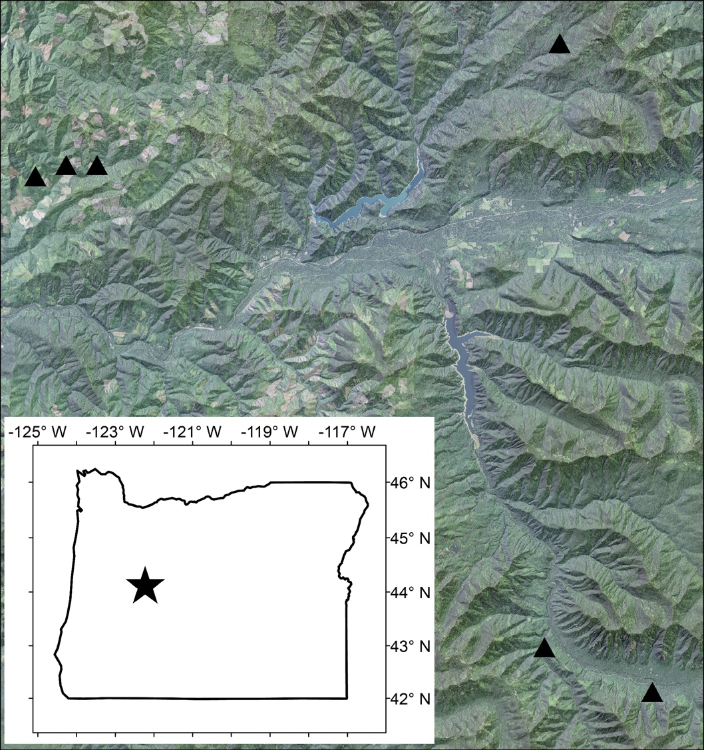

**McTE**

**W-122**

**W-100**

**W-113**

**Chucksney**

**Loon**

Figure 1.2: Temperature logger locations

Diagram of the stream sites containing one reference reach and a treatment reach separated by a buffer reach. Temperature loggers were located every 30 meters.



Figure 1.3: Reach differences by year of shade and light

Differences in stream shade (1-GSF) (a) and mean daily PAR in moles m-2 day-1 (b) between the treatment reach and the reference reach for each year by site. Reach differences in shading decreased and reach differences in mean daily PAR increased in the post-treatment year.

**Shade Light**

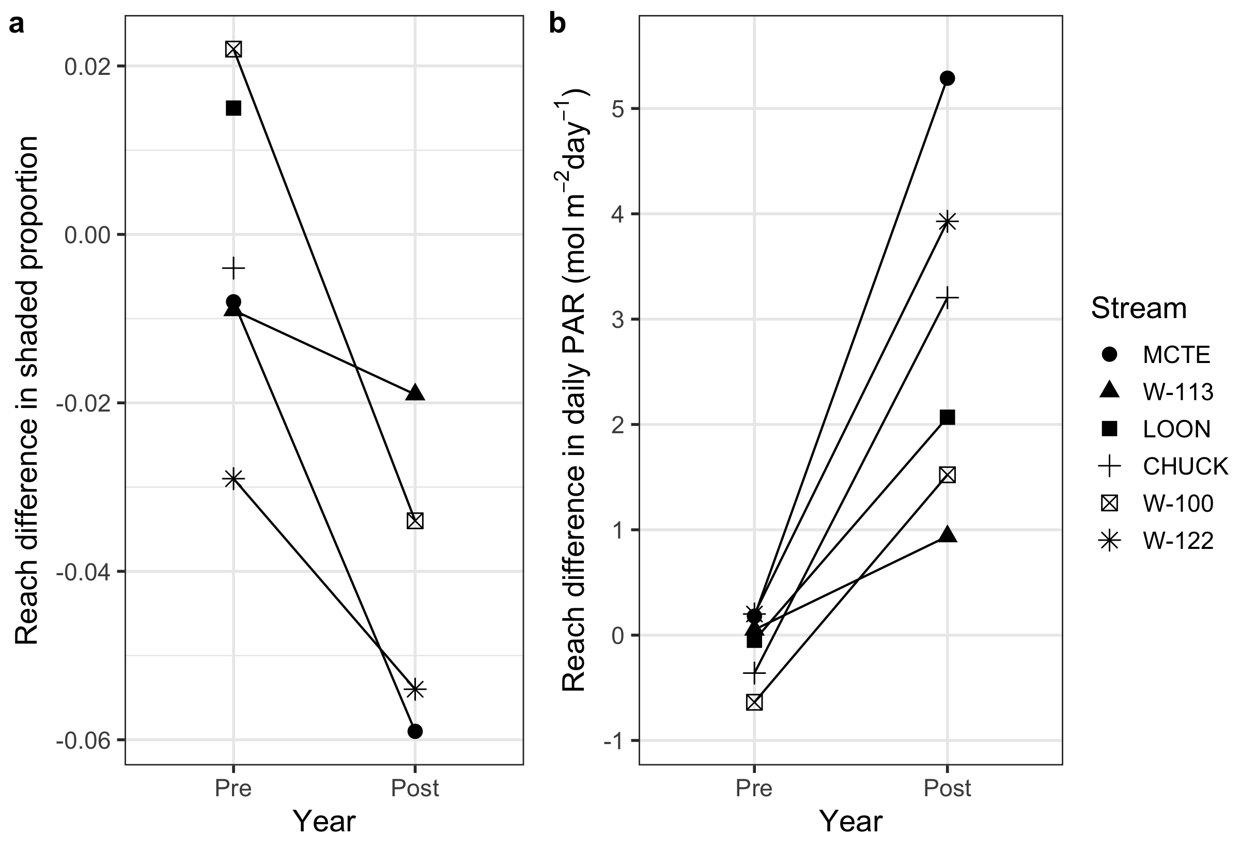

Figure 1.4: Maximum 7 day moving average maximum temperatures

Maximum 7 day moving average maximum temperatures (T7DayMax) at the downstream end of each reach for the treatment reaches (red) and the references reaches (blue) before and after the gaps were cut. Grey dashed lines are at 16oC.

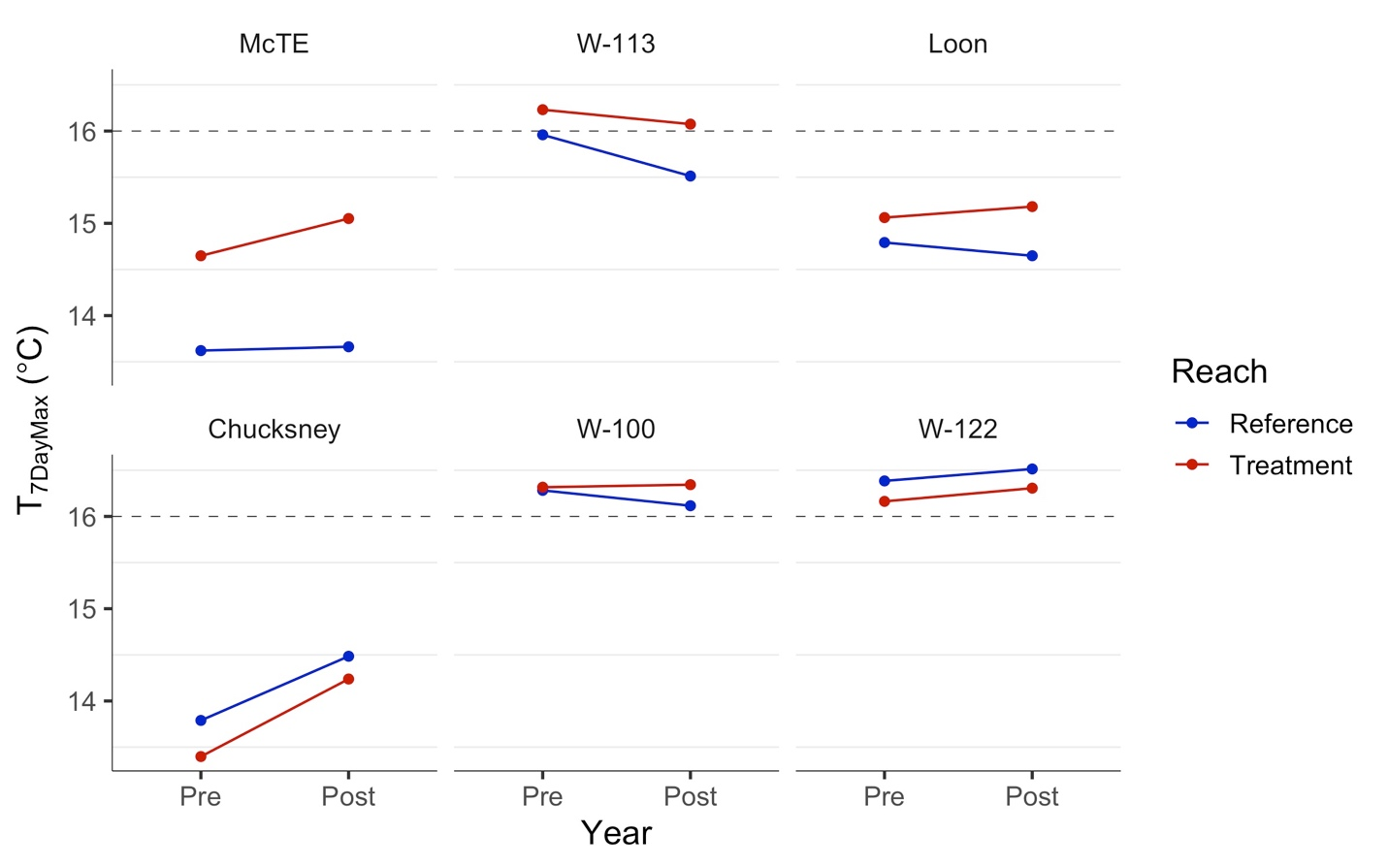

Figure 1.5: Maximum daily temperature yearly regressions

Yearly comparisons of regression relationships for the reference reach (x-axis) versus the treatment reach (y-axis) of maximum daily downstream temperatures values and 95 percent confidence intervals (grey). Sites are ordered by stream size (bankfull width).



Figure 1.6: Longitudinal temperatures

Longitudinal T7DayMax temperatures. Yellow shaded areas are the extent of the additional light from the canopy gap in the treatment reach only. Pre-treatment and reference reach data show inherent variability in T7DayMax along reach and between reaches and post-cut treatment reach data show increases due to the gap.

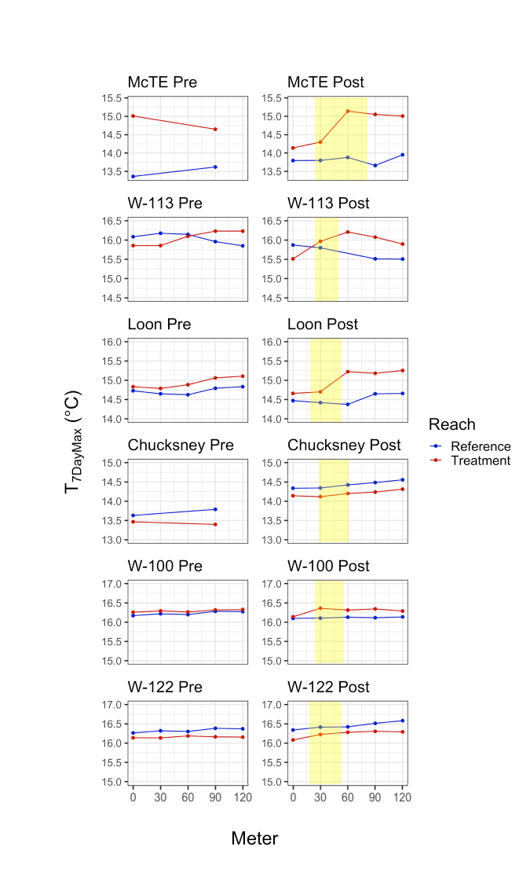

Figure 1.7: Explanatory variables of the maximum 7 day moving average temperature response

Fitted linear regressions of explanatory variables for the T7DayMax response showing strong relationships with discharge (c) and bankful width (d), but not with light (a) or gap area (b).

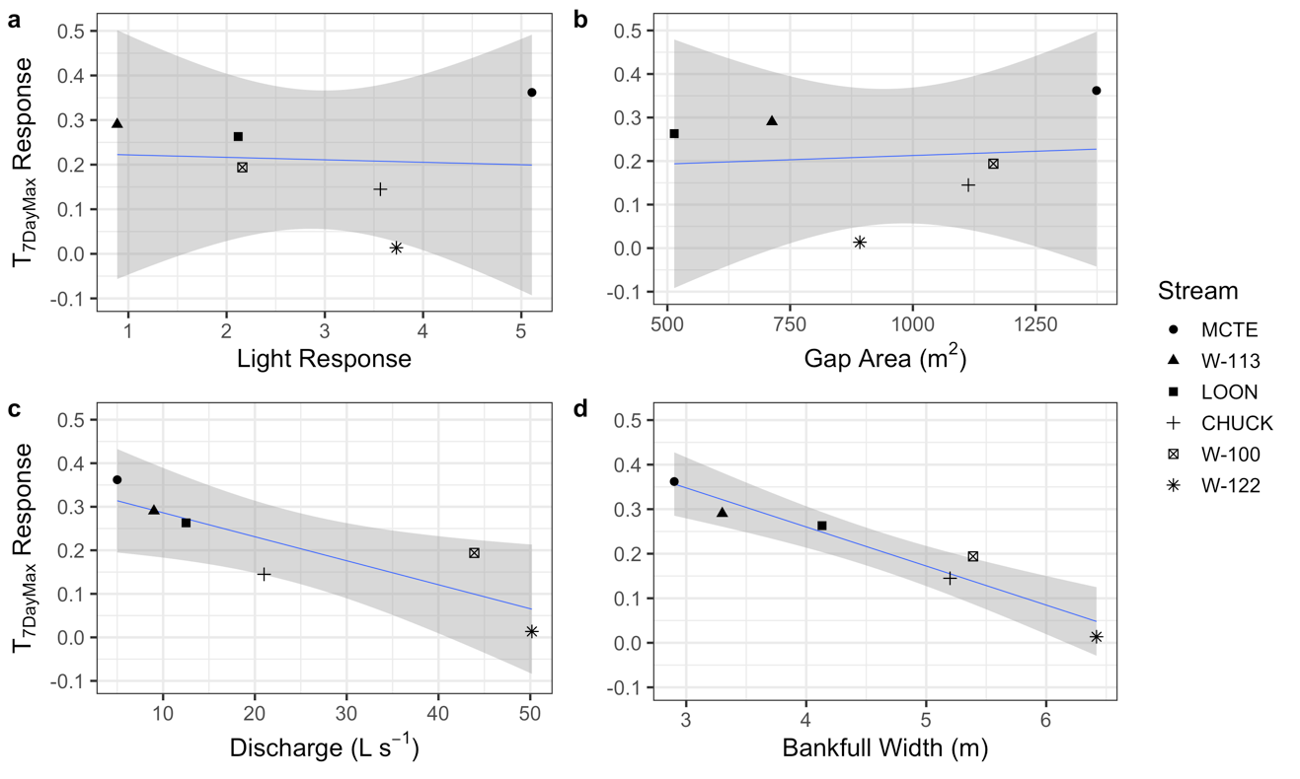

r2 = 0.005

p = 0.899

r2 = 0.011

p = 0.849

r2 = 0.926

p = 0.002

r2 = 0.728

p = 0.031

Table 1.1: Site description details of the six streams

Site details including elevation, coordinates, bankful width, gap size, and baseflow discharge.

|  |  |  |  |  |  |  |
| --- | --- | --- | --- | --- | --- | --- |
| **Stream** | **Elevation (m)** | **Latitude** | **Longitude** | **Bankful Width (m)** | **Gap Size (m2)** | **Baseflow Discharge (L s-1)** |
| McTE | 867 | 44.254544 | -122.166720 | 2.20 | 1374 | 5.0 |
| W-113 | 537 | 44.192892 | -122.510742 | 3.30 | 713 | 9.1 |
| Loon | 721 | 43.953624 | -122.183330 | 4.13 | 514 | 12.5 |
| Chucksney | 833 | 43.953624 | -122.113550 | 5.20 | 1113 | 21.0 |
| W-100 | 441 | 44.198130 | -122.492983 | 5.39 | 1164 | 43.9 |
| W-122 | 393 | 44.195514 | -122.467184 | 6.42 | 892 | 50.2 |

Table 1.2: Overall temperature responses for six metrics across all the stream sites

Responses (changes in reach differences before and after the cut) of T7DayMax, T7DayMean,average daily mean and average daily maximum, as well as changes in the slopes for the yearly reference versus treatment reach relationships of daily maximums and daily means.

|  |  |  |  |  |  |  |
| --- | --- | --- | --- | --- | --- | --- |
| **Stream** | **T7DayMax**  **Response**  **(oC)** | **T7DayMean**  **Response**  **(oC)** | **Avg. Daily Max**  **Response**  **(oC)** | **Avg. Daily Mean**  **Response**  **(oC)** | **Δ in Slope- Daily Maxes**  **(oC/oC)** | **Δ in Slope- Daily Means**  **(oC/oC)** |
| McTE | 0.362 | 0.443 | 0.530 | 0.271 | 0.344 | 0.218 |
| W-113 | 0.290 | 0.068 | 0.243 | 0.093 | 0.046 | -0.010 |
| Loon | 0.263 | 0.091 | 0.246 | 0.069 | 0.064 | 0.058 |
| Chucksney | 0.145 | 0.099 | 0.157 | 0.127 | 0.022 | 0.011 |
| W-100 | 0.194 | 0.134 | 0.224 | 0.117 | 0.061 | 0.025 |
| W-122 | 0.014 | 0.076 | -0.047 | 0.088 | 0.036 | -0.005 |

Chapter 2: Influence of riparian canopy gaps on stream periphyton

**Introduction**

Light is a fundamental resource for primary production, and ultimately accrual of autotrophic biomass in both aquatic and terrestrial ecosystems. In forested headwater streams, primary production within the aquatic system (autochthonous production) contributes disproportionately to nutrient demand (Mulholland et al. 2008), and to the growth of top aquatic consumers (McCutchan and Lewis 2002), compared to generally more abundant but lower quality terrestrial carbon inputs (allochthonous). Therefore, changes in the amount of primary production—even small changes—may significantly influence stream ecosystem processes and stream biota. Across the Pacific Northwest stream primary production is often low as many headwater riparian areas have forests in the early to middle phases of stand development leading to light limitation of primary producers in associated streams (Warren et al. 2016). Natural and anthropogenic processes that create canopy gaps in the riparian forest will create patches of elevated light, which could enhance benthic primary production and other aquatic ecosystem processes. Canopy manipulation treatments designed to emulate natural disturbances have been suggested as a tool to increase complexity of riparian forests and potentially elevate stream primary and secondary production without impacting other components of the stream ecosystem (Kreutzweiser et al. 2012, Moore and Richardson 2012). However, little research has examined the impacts of managing for complex riparian canopies on streams. The goal of this study is to inform our understanding of how natural stand development processes, as well as riparian forest management designed to mimic that process, may affect biological and ecological processes in headwater streams.

Photosynthesis is the process of converting light energy to reduced carbon (organic substances) by photosynthetic autotrophs. In streams, primary production can be measured directly by saturation deficits in dissolved oxygen (a byproduct of photosynthesis that accumulates at a rate proportional to the photosynthetic rate when corrected for respiration), or through net photosynthesis proxies in the stream periphyton such as biomass and chlorophyll *a* accrual over time. Periphyton is a biofilm matrix of algae, heterotrophic bacteria, and diatoms found on bed substrates. Periphyton is the dominant food source for many stream consumers (e.g. scrapers and grazers) and, therefore, the quantity and quality of periphyton can control habitat quality for many stream biota (Peterson 1993). Benthic biofilms also plays a crucial role in nutrient cycling, with the potential to control the quantity and timing of nutrient transport downstream (Mulholland and Rosemond 1992, Mulholland et al. 2008).

The amount of photosynthetically active radiation (PAR) can be the primary factor limiting autotrophic production when the riparian forests are in the stem exclusion phase and light levels reaching the stream are low. The difference in summer light fluxes below the canopy of old-growth versus second growth riparian forests is illustrated by daily accumulated PAR at the East tributary of McRae Creek (Figure 2.1). In these stream reaches, periphyton standing stocks in summer are lower on average in the streams within second growth riparian forests than of those within old-growth forests. But light is limiting along sections of stream in most of these systems, independent of stand age (Warren et al. 2017), and when these streams received more light they tend of have higher availability of chlorophyll *a* on the stream benthos (Kaylor and Warren 2017, Heaston et al. 2018). But light alone does not drive primary production and increases are not consistent across all points in a reach or the same magnitude across streams. In old-growth forests, small areas of elevated, high intensity, light can be hotspots for primary production (Stovall et al. 2009, Warren et al. 2016), thereby elevating the mean abundance of periphyton (McClain et al. 2003, Kiffney et al. 2006).

Much of the research on responses of primary production to riparian canopy manipulations have focused on clear-cut riparian forest harvest. In a review assessing these responses, I found that as the light manipulation ratio increased (the ratio of light after canopy removal compared to before removal), the response ratios (ratio of ash free dry mass (AFDM), chlorophyll *a*, and GPP after canopy removal compared to before removal) also increased. This collection of research also highlights that little is known about the responses to light manipulation ratios between 3 and 23, which are small or moderate changes in canopy cover such as canopy gaps (Figure 2.2). Because light is not the only requirement for primary production, responses to light manipulations can also be influenced by nutrient availability and response relationships can be affected by photosaturation.

Changes in light may drive bottom up pathways of the food web (Kiffney et al. 2003, Matheson et al. 2012, Wootton 2012). Allochthonous carbon (e.g., leaf litter and terrestrial invertebrate inputs) is an important food source for secondary consumers in forested headwaters (Fisher and Likens 1972, Wallace 1997, Wallace et al. 1999), however, there is increasing evidence that autochthonous carbon (periphyton) may be a disproportionally important to consumers because it is a high quality (low C to N ratio) food resource (Finlay 2001, McCutchan and Lewis 2002, Brito et al. 2006, Lau et al. 2009). Therefore, having increased light to produce more higher quality food could lead to increased energy transfer to higher trophic levels (Bilby and Bisson 1992). Further, reductions in canopy cover may cause changes in primary production that could also influence consumers.

Methods

Spatial light

Light flux to the stream bed was measured every 5 meters throughout each reach using photodegrading fluorescein dye (Bechtold et al. 2012). Fluorescein degrades at a predictable rate when exposed to light and can be used to quantify relative light availability in streams (Bechtold et al. 2012, Warren et al. 2013). We mixed concentrated fluorescein with deionized water to a concentration of 400 g/L and added 40 g/L of commercial aquarium salt (InstantOcean®) to buffer the solution. We filled 3.7-mL clear glass vials with the premixed solution and used zip ties to attach 3 vials to a single wire flag at each sampling location. Every 4th flag had a vial wrapped in aluminum foil to serve as a control to correct for drift in concentration.

﻿ After 24 hours, we returned the flags to the laboratory and allowed them to warm to room temperature because fluorescence readings are affected by solution temperature (Bechtold et al. 2012). We measured fluorescence with an AquaFluor handheld fluorometer (Turner Designs, San Jose, California). Fluorescence readings for each flag/location were averaged across the 3 replicates and subtracted from the mean fluorescence value of the field-dark controls to produce average and standard error photodegradation values for each location. Fluorescein decay was then converted to daily PAR using the relationship established from sites in the HJ Andrews Experimental Forest (Warren et al. 2017).

Chlorophyll a

Periphyton chlorophyll *a* was quantified on 10 ceramic tiles (15 x 15 cm) per reach. Tiles were placed in the stream in mid-July and were retrieved after six weeks. Tiles were spaced at regular intervals and positioned within riffle sections of the stream at a depth of 10-25 cm. In situ chlorophyll *a* measurements were conducted using a BenthoTorch (BBE Moldaenke GmbH). The BenthoTorch is a portable field instrument used for the quantification of chlorophyll *a* fluorescence on different substrates and provides a real-time measurement of benthic algae concentrations (Kahlert and McKie 2014). The BenthoTorch has been shown to accurately quantify periphyton biomass expressed as chlorophyll *a* µg cm-2 (Kahlert and McKie 2014). Data before the cut in the reference reach at Chucksney were unavailable.

Data Analysis

In order to identify the effects of the gap on stream light and chlorophyll *a* we fit a linear mixed-effects model fit by REML using the nlme package ﻿(Pinheiro et al., 2016) in R (R Core Team, 2014) to the data. The response variable, Yt, is the observed PAR value for that reach. The same model was applied to detect responses in chlorophyll *a*. The fixed effects included Year (Pre or Post), Reach (Reference or Treatment), and the BACI effect, which is the interaction term of Year and Reach identifying the effect of the imposed gap. Additionally, random effects for Stream and Reach were included as nested random effects and the assumption of constant variance was relaxed.

Yt = Year + Reach + BACI + (1|~Stream/Reach) + εt

Where εt is the random effect term for the *tth* group, where εt ~ N(0, σε2) and εt and εt’ are independent.

Results

Light

Daily PAR in the year before the cut was consistently low in study reaches across all 6 sites. In the year after the cut, daily PAR values remained consistently low in the reference reaches, while values increased dramatically in the treatment reach in the localized area below the cut (Figure 2.3). The light effect surrounded meter 30 of each treatment reach, and extended an average of 29.17 meters along the treatment reaches and ranged from 20-40 meters. The effect of the gap on light is obvious from the spatial light data, and when data were averaged over the reaches (Figure 2.4), the gap has a statistically significant effect on light (p = 0.0004)(Appendix A.7).

Light responses varied across the sites. The largest extent of increased light was seen at the site McTE. The largest magnitude increase was at Chucksney which increased from 1.12 to 17.85 mol m-2 day-1 at meter 50. Site W-113 had the smallest increase both in extent and magnitude, however spatially, the localized effect of the gap on light is still clear.

*Chlorophyll a*

Chlorophyll *a* standing stocks on tiles in the year before the cut were consistently low between reaches at each site and across all 6 sites (Figure 2.5). In the year after the cut, chlorophyll *a* values were generally low in the reference reach, with exception of the reference reach at Chucksney. In the treatment reaches after the cut, chlorophyll *a* values were higher than the reference reach and the pre-treatment data at the meter locations within the middle of the reaches, but stayed low at the top and bottom of the reaches (Figure 2.5). The mean chlorophyll *a* response was 0.225 (ug cm-2). Chlorophyll *a* increased dramatically at Chucksney meter 40 and Loon meter 50, consistent with areas of increased light. When 10 meter data points were averaged over the reaches (Figure 2.6), increases in the treatment reaches after the cut at Loon and Chucksney were within the standard error of the reference reaches after the cut, but across the six sites, the gap has a statistically significant effect on reach mean chlorophyll *a* (p = 0.015)(Appendix A.7).

We regressed the chlorophyll *a* response at each site against the light response, gap size, discharge (L/s), bankfull width, T7DayMax response, background nitrogen concentrations (N-NO3-), background phosphorus concentrations (P-PO4-) and background nitrogen to phosphorus ratios in each stream. The strongest explanatory variable was background nitrogen concentrations across the five sites (r2 = 0.650, p = 0.099) with no other variables being well correlated (Figure 2.7).

Discussion

The importance of canopy gaps, and more broadly the potential effect of increases in streamside forest complexity on stream ecosystem productivity have been hypothesized, but no empirical field studies have quantified how local light patches due to canopy gaps affect primary producers. The goal of this study was to understand how development of complex canopy structure in the riparian forest will influence headwater stream ecosystem function.

Light reaching the stream in natural systems such as late successional forests can be highly spatially variable due to forest complexity (Keeton et al. 2007, Stovall et al. 2009, Warren et al. 2013). This heterogeneity in the light environment is important when assessing stream ecosystem responses as periphyton communities and biomass are closely associated with light (Boston and Hill 1991). Directly below the gap light increased approximately 10-fold which also resulted in reach scale increases with strongly statistically significant effects of the gap on daily reach scale light availability to the stream bed.

Light is a fundamental control on in-stream ecosystem processes such as primary production and nutrient cycling. In light limited forested headwater streams, increases in light have been shown to cause increases in primary production and consumer biomass (Hill et al. 1995). Riparian forest structure and harvest manipulations directly impact stream ecosystems by altering the availability of light to the stream, however, most riparian manipulations thus far have been primarily focused on clear-cuts, as opposed to smaller or more variable manipulations. Past clear-cut studies resulted in large increases in the autotrophic responses (Wootton 2012). Additionally, large increases in primary producers were found in a study altering light levels over experimental channels (Kiffney et al. 2004, Matheson et al. 2012), and along light gradients in natural prairie systems (Denicola et al. 1992). Although gaps are small scale manipulations in light and background variability in chlorophyll *a* occurs in natural systems, the effect of gaps in this study showed spatially explicit increases in chlorophyll *a*. The gap manipulations in this study increased chlorophyll *a* locally, but this response is more relevant at the reach scale. The mean responses show that the gap increased chlorophyll *a* at the reach scale also, suggesting a higher frequency of gaps along a stream or in a watershed could lead to increased chlorophyll *a* at larger scales.

Chlorophyll *a* on tiles is a proxy from primary production and can differ from chlorophyll *a* standing stocks on natural substrates due to differences in colonization, establishment, and invertebrate consumption. However, due to the BACI study design, the effect of the gap results in increases chlorophyll *a* on tiles suggesting increased primary productivity due to the increase in light. These increases in primary productivity can then contribute to increased food availability to higher level consumers. Tiles were used to explicitly understand if riparian canopy gaps have an effect on chlorophyll *a*. Additionally, the benthotorch has limitations (Kaylor et al. 2018) due to algae thickness and other factors common when dealing with natural substrates, so that made the use of tiles is most appropriate for our study questions.

With increases in light and chlorophyll *a*, potential photosaturation is possible and in forested headwater streams, photosaturation occurs at a photon flux density of approximately 400µm m-2 s-1 (Boston and Hill 1991). After this threshold is reached, other factors can become limiting such as nutrients, as exemplified in streams within old-growth forest where areas of high light to the stream have large amounts of periphyton growth, but in areas of elevated light, nutrients become limiting (Warren et al. 2016). The mass of periphyton could further account for increases in light because ratios of chlorophyll *a* to periphyton AFDM can shift. AFDM can be additionally relevant to assess food availability for higher level consumers.

Due to the deprivation of light in these systems, we hypothesized that the variability in light response would be a strong predictor of the variability in chlorophyll *a* response. Although the BACI analysis shows strong effects of the gap, the variability within chlorophyll *a* responses was not well explained by the variability in light responses across the five sites. However, chlorophyll *a* is not solely dependent on light, and nutrient availability is also an important control. The potential for a single limiting factor to control primary production and a wide range of associated ecosystem processes is a fundamental concept in ecology; however, recent syntheses have highlighted the importance and prevalence of co-limitation (limitation of primary production by two or more factors together) rather than single-factor limitation at the community and ecosystem scale (Elser et al. 2007, Danger et al. 2008, Harpole et al. 2011, Sperfeld et al. 2012).

Nutrients and stream light availability are two resources that are strongly influenced by historic and ongoing anthropogenic activities (Vitousek et al. 1997, Warren et al. 2013). Other studies have demonstrated that highly shaded streams are light limited and that stream primary production shifts to nutrient limitation when shade is removed (Bernhardt and Likens 2004, Von Schiller et al. 2007, Koenig et al. 2017). The strong correlation between background nitrogen concentration (in the form of nitrate) and the variability in chlorophyll *a* supports the hypothesis of co-limitation in these systems and highlights the importance of understanding how the background context of your system will affect how it responds to increases in light. Primary production influences the processing, retention, and export of carbon and nutrients in an ecosystem; therefore, identifying the factors that influence primary production enhances our understanding of how multiple components of an ecosystem are likely to respond to changing environmental conditions (Vitousek et al. 1997, Grimm et al. 2013, Rosemond et al. 2015).

Conclusion

In mid-succession forests, the canopy over headwater streams is simple, but canopy structure is dynamic through space and through time, developing complexity as stands age and in response to natural disturbances (Denslow and Spies 1990). Gaps create patches of light in the stream that enhance autotrophic abundance at the reach scale. Increases in primary productivity are dependent on changes in light and will vary as stands develop more complex structure, but also vary based on nutrient availability which can too be influenced by land use change. As terrestrial ecosystems change over time due to natural progression or management activities, we can expect to see changes in the light environment driving stream ecosystem processes. Light increases will interact with background nutrient availability to create hotspots for primary productivity and nutrient cycling in streams.

**References**

Bechtold, H. A., E. J. Rosi-Marshall, D. R. Warren, and J. J. Cole. 2012. A practical method for measuring integrated solar radiation reaching streambeds using photodegrading dyes. Freshwater Science 31:1070–1077.

Bernhardt, E. S., and G. E. Likens. 2004. Controls on periphyton biomass in heterotrophic streams. Freshwater Biology 49:14–27.

Bilby, R. E., and P. A. Bisson. 1992. Allochthonous versus Autochthonous Organic Matter Contributions to the Trophic Support of Fish Populations in Clear-Cut and Old-Growth Forested Streams. Canadian Journal of Fisheries and Aquatic Sciences 49:540–551.

Boston, H. L., and W. R. Hill. 1991. Photosynthesis-light relations of stream periphyton communities. Limnol. Oceanogr 36:644–656.

Brito, E. F., T. P. Moulton, M. L. De Souza, and S. E. Bunn. 2006. Stable isotope analysis indicates microalgae as the predominant food source of fauna in a coastal forest stream, south-east Brazil. Austral Ecology 31:623–633.

Danger, M., T. Daufresne, F. Lucas, S. Pissard, and G. Lacroix. 2008. Does Liebig’s law of the minimum scale up from species to communities? Oikos 117:1741–1751.

Denicola, D. M., K. D. Hoagland, S. C. Roemer, M. DeNicola, K. D. Hoagland, and S. C. Roemer. 1992. Influences of canopy cover on spectral irradiance and periphyton assemblages in a prairie stream. Journal Of The North American Benthological Society 11:391–404.

Denslow, J. S., and T. A. Spies. 1990. Canopy gaps in forest ecosystems: an introduction. Canadian Journal of Forest Research 25:1341–1354.

Elser, J. J., M. E. S. Bracken, E. E. Cleland, D. S. Gruner, W. S. Harpole, H. Hillebrand, J. T. Ngai, E. W. Seabloom, J. B. Shurin, and J. E. Smith. 2007. Global analysis of nitrogen and phosphorus limitation of primary producers in freshwater, marine and terrestrial ecosystems. Ecology Letters 10:1135–1142.

Finlay, J. C. 2001. Stable carbon isotope ratios of river biota:Implications for energy flow in lotic food webs. Ecology 82:1052–1064.

Fisher, S. G., and G. E. Likens. 1972. Stream Ecosystem: Organic Energy Budget. Source: BioScience 22:33–35.

Grimm, N. B., F. S. Chapin, B. Bierwagen, P. Gonzalez, P. M. Groffman, Y. Luo, F. Melton, K. Nadelhoffer, A. Pairis, P. A. Raymond, J. Schimel, and C. E. Williamson. 2013. The impacts of climate change on ecosystem structure and function. Frontiers in Ecology and the Environment 11:474–482.

Harpole, W. S., J. T. Ngai, E. E. Cleland, E. W. Seabloom, E. T. Borer, M. E. S. Bracken, J. J. Elser, D. S. Gruner, H. Hillebrand, J. B. Shurin, and J. E. Smith. 2011. Nutrient co-limitation of primary producer communities. Ecology Letters 14:852–862.

Heaston, E. D., M. J. Kaylor, and D. R. Warren. 2018. Aquatic food web response to patchy shading along forested headwater streams. Canadian Journal of Fisheries and Aquatic Sciences 75:2211–2220.

Hill, W. R., M. G. Ryon, and E. M. Schilling. 1995. Light Limitation in a Stream Ecosystem: Responses by Primary Producers and Consumers. Ecology 76:1297–1309.

Kahlert, M., and B. G. McKie. 2014. Comparing new and conventional methods to estimate benthic algal biomass and composition in freshwaters. Environ. Sci.: Processes Impacts 16:2627–2634.

Kaylor, M. J., A. Argerich, S. M. White, B. J. VerWey, and I. Arismendi. 2018. A cautionary tale for in situ fluorometric measurement of stream chlorophyll *a* : influences of light and periphyton biomass. Freshwater Science 37:287–295.

Kaylor, M. J., and D. R. Warren. 2017. Linking riparian shade and the legacies of forest management to fish and vertebrate biomass in forested streams. Ecosphere 8:e01845.

Keeton, W. S., C. E. Kraft, and D. R. Warren. 2007. Mature and old-growth riparian forests: Structure, dynamics, and effects on adirondack stream habitats. Ecological Applications 17:852–868.

Kiffney, P. M., C. M. Greene, J. E. Hall, and J. R. Davies. 2006. Tributary streams create spatial discontinuities in habitat, biological productivity, and diversity in mainstem rivers. Canadian Journal of Fisheries and Aquatic Sciences 63:2518–2530.

Kiffney, P. M., J. S. Richardson, and J. P. Bull. 2003. Responses of periphyton and insects to experimental manipulation of riparian buffer width along forest streams. Journal of Applied Ecology 40:1060–1076.

Kiffney, P. M., J. S. Richardson, and J. P. Bull. 2004. Establishing light as a causal mechanism structuring stream communities in response to experimental manipulation of riparian buffer width. Journal of the North American Benthological Society 23:542–555.

Koenig, L. E., C. Song, W. M. Wollheim, J. Rüegg, and W. H. McDowell. 2017. Nitrification increases nitrogen export from a tropical river network. Freshwater Science 36.

Kreutzweiser, D. P., P. K. Sibley, J. S. Richardson, and A. M. Gordon. 2012. Introduction and a theoretical basis for using disturbance by forest management activities to sustain aquatic ecosystems. Freshwater Science 31:224–231.

Lau, D. C. P., K. M. Y. Leung, and D. Dudgeon. 2009. Are autochthonous foods more important than allochthonous resources to benthic consumers in tropical headwater streams? Journal of the North American Benthological Society 28:426–439.

Matheson, F. E., J. M. Quinn, and M. L. Martin. 2012. Effects of irradiance on diel and seasonal patterns of nutrient uptake by stream periphyton. Freshwater Biology 57:1617–1630.

McClain, M. E., E. W. Boyer, C. L. Dent, S. E. Gergel, N. B. Grimm, P. M. Groffman, S. C. Hart, J. W. Harvey, C. A. Johnston, E. Mayorga, W. H. McDowell, and G. Pinay. 2003, June. Biogeochemical Hot Spots and Hot Moments at the Interface of Terrestrial and Aquatic Ecosystems. Springer-Verlag.

McCutchan, J. H., and W. M. Lewis. 2002. Relative importance of carbon sources for macroinvertebrates in a Rocky Mountain stream. Limnology and Oceanography 47:742–752.

Moore, R. D., and J. S. Richardson. 2012. Natural disturbance and forest management in riparian zones: comparison of effects at reach, catchment, and landscape scales. Freshwater Science 31:239–247.

Mulholland, P. J., A. M. Helton, G. C. Poole, R. O. Hall, S. K. Hamilton, B. J. Peterson, J. L. Tank, L. R. Ashkenas, L. W. Cooper, C. N. Dahm, W. K. Dodds, S. E. G. G. Findlay, S. V. Gregory, N. B. Grimm, S. L. Johnson, W. H. McDowell, J. L. Meyer, H. M. Valett, J. R. Webster, C. P. Arango, J. J. Beaulieu, M. J. Bernot, A. J. Burgin, C. L. Crenshaw, L. T. Johnson, B. R. Niederlehner, J. M. O’Brien, J. D. Potter, R. W. Sheibley, D. J. Sobota, S. M. Thomas, J. M. O’Brien, J. D. Potter, R. W. Sheibley, D. J. Sobota, and S. M. Thomas. 2008. Stream denitrification across biomes and its response to anthropogenic nitrate loading. Nature 452:202–205.

Mulholland, P. J., and A. D. Rosemond. 1992. Periphyton response to longitudinal nutrient depletion in a woodland stream: evidence of upstream-downstream linkage. Journal of the North American Benthological Society 11:405–419.

Peterson, B. J. 1993, April. Biological responses of a tundra river to fertilization. Ecological Society of America.

Rosemond, A. D., J. P. Benstead, P. M. Bumpers, V. Gulis, J. S. Kominoski, D. W. P. Manning, K. Suberkropp, and J. B. Wallace. 2015. Freshwater ecology. Experimental nutrient additions accelerate terrestrial carbon loss from stream ecosystems. Science (New York, N.Y.) 347:1142–5.

Von Schiller, D., E. Martí, J. L. Riera, and F. Sabater. 2007. Effects of nutrients and light on periphyton biomass and nitrogen uptake in Mediterranean streams with contrasting land uses. Freshwater Biology 52:891–906.

Sperfeld, E., D. Martin-Creuzburg, and A. Wacker. 2012. Multiple resource limitation theory applied to herbivorous consumers: Liebig’s minimum rule vs. interactive co-limitation. Ecology Letters 15:142–150.

Stovall, J. P., W. S. Keeton, and C. E. Kraft. 2009. Late-successional riparian forest structure results in heterogeneous periphyton distributions in low-order streams. Canadian Journal of Forest Research 39:2343–2354.

Vitousek, P. M., H. A. Mooney, J. Lubchenco, and J. M. Melillo. 1997. Human Domination of Earth’s Ecosystems. Science 277:494–499.

Wallace, J. B. 1997. Multiple Trophic Levels of a Forest Stream Linked to Terrestrial Litter Inputs. Science 277:102–104.

Wallace, J. B., S. L. Eggert, J. L. Meyer, and J. R. Webster. 1999. Effects of resource limitation on a detrital-based ecosystem. Ecological Monographs 69:409–442.

Warren, D. R., S. M. Collins, E. M. Purvis, M. J. Kaylor, and H. A. Bechtold. 2017. Spatial Variability in Light Yields Colimitation of Primary Production by Both Light and Nutrients in a Forested Stream Ecosystem. Ecosystems 20:198–210.

Warren, D. R., W. S. Keeton, H. A. Bechtold, and E. J. Rosi-Marshall. 2013. Comparing streambed light availability and canopy cover in streams with old-growth versus early-mature riparian forests in western Oregon. Aquatic Sciences 75:547–558.

Warren, D. R., W. S. Keeton, P. M. Kiffney, M. J. Kaylor, H. A. Bechtold, and J. Magee. 2016. Changing Forests – Changing Streams: Riparian forest stand development and ecosystem function in temperate headwaters. Ecosphere 7:1–19.

Wootton, J. T. 2012. River Food Web Response to Large-Scale Riparian Zone Manipulations. PLoS ONE 7:e51839.

Figure 2.1: Spatial daily PAR

Photosynthetically active radiation (PAR) on the stream benthos over 24 hours at McRae Creek Tributary - East in the HJ Andrews Experimental Forest, OR. Large differences in magnitude and variability are seen between the old-growth (blue) and second-growth (<70 years old) reaches (adapted from Warren et al., 2016a).



Figure 2.2: Spatial daily PAR

Compiled data from available canopy manipulation studies showing increasing trends in response ratios of primary productivity, periphytic chlorophyll *a* and AFDM as a function of the light manipulation ratio from the riparian canopy removal. No data is available for treatments resulting in light manipulation ratios between 3 and 23 (small to moderate changes in canopy cover).



Figure 2.3: Spatial daily PAR

Average and standard error for PAR (photosynthetically active radiation) every 5 meters in reference (blue) and treatment (gold) reaches for the years before (open triangles) and after (filled circles) the cut.

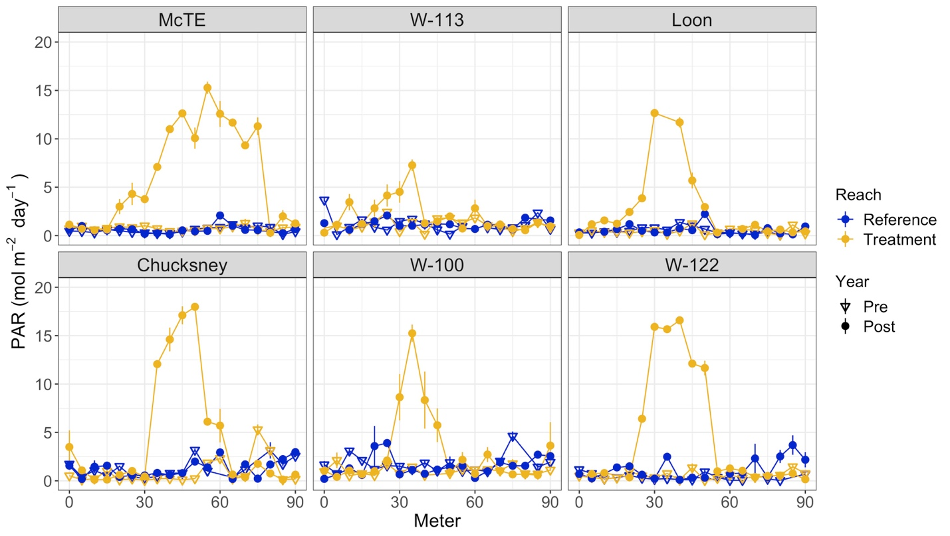

Figure 2.4: Reach averages of daily PAR

Reach scale averages and standard error for PAR (photosynthetically active radiation) in reference (blue) and treatment (gold) reaches for the years before and after the cut.

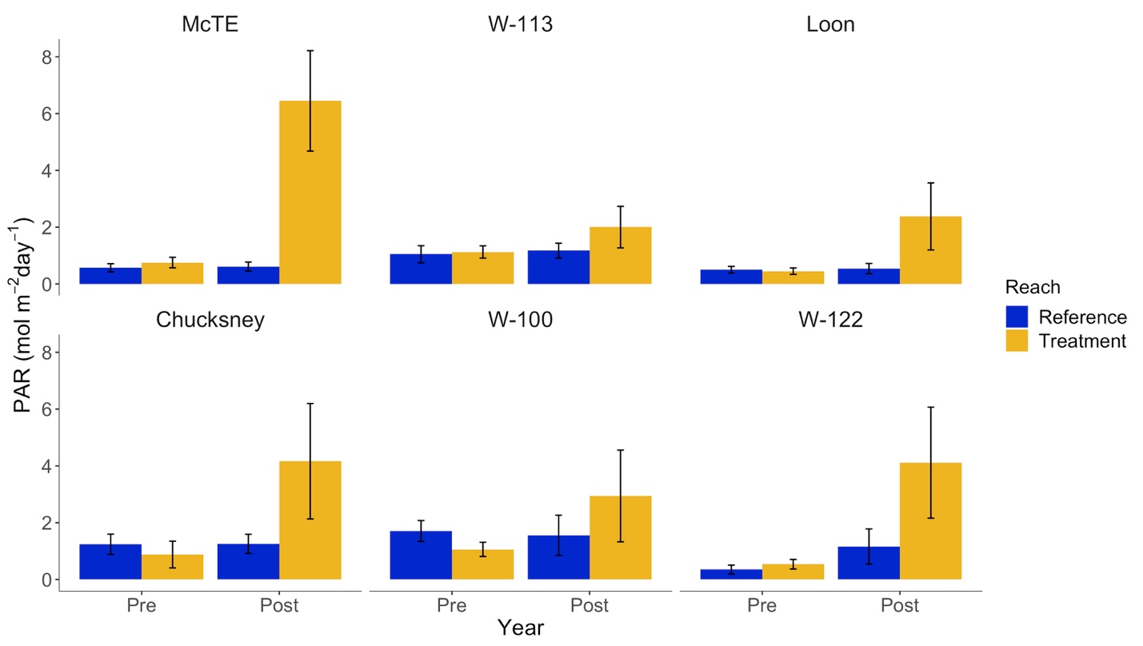

Figure 2.5: Spatial chlorophyll *a*

Average and standard error for chlorophyll *a* (ug cm-2) every 10 meters in reference (blue) and treatment (gold) reaches for the years before (open triangles) and after (filled circles) the cut. Data before the cut in the reference reach at Chucksney were unavailable.

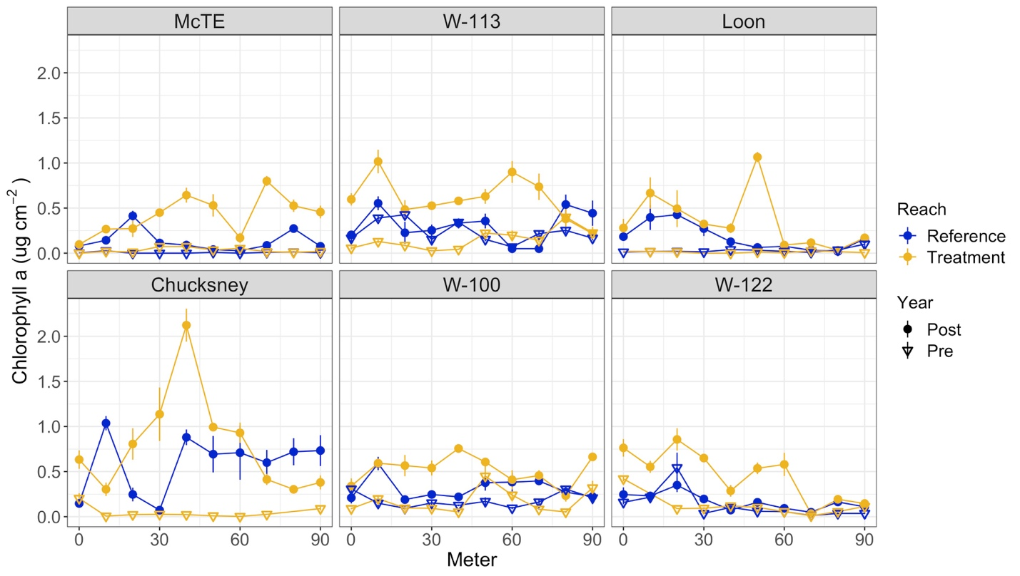

Figure 2.6: Reach averages of chlorophyll *a*

Reach scale averages and standard error for chlorophyll *a* (ug cm-2) standing stocks on tiles in reference (blue) and treatment (gold) reaches for the years before and after the cut.

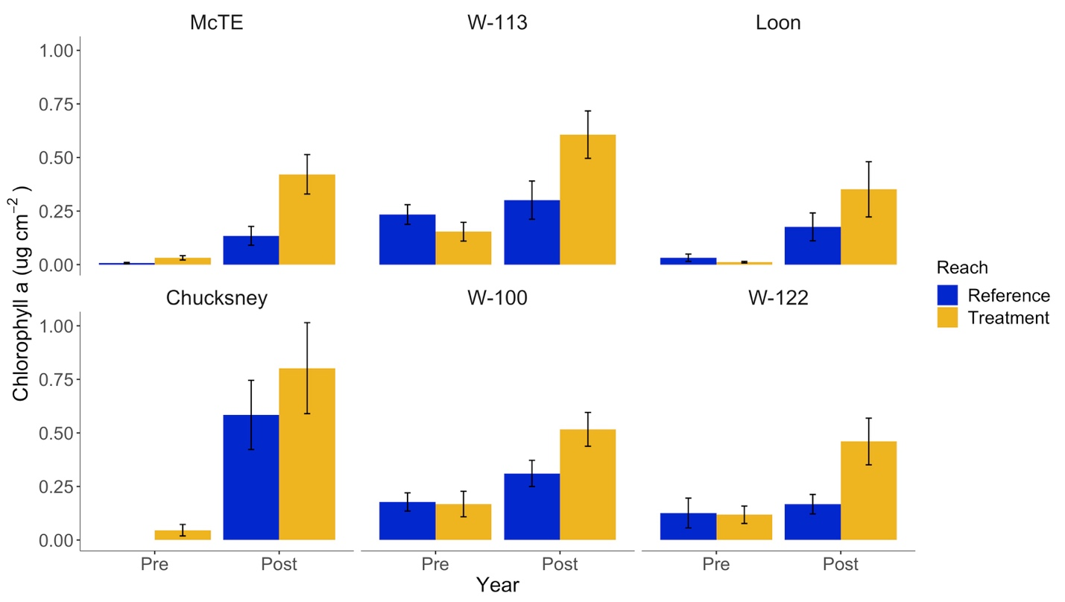

Figure 2.7: Explanatory variables of chlorophyll *a* responses

Fitted linear regressions of explanatory variables for the chlorophyll *a* response, discharge (c) and bankfull width (d), but not with light (a) or gap area (b).

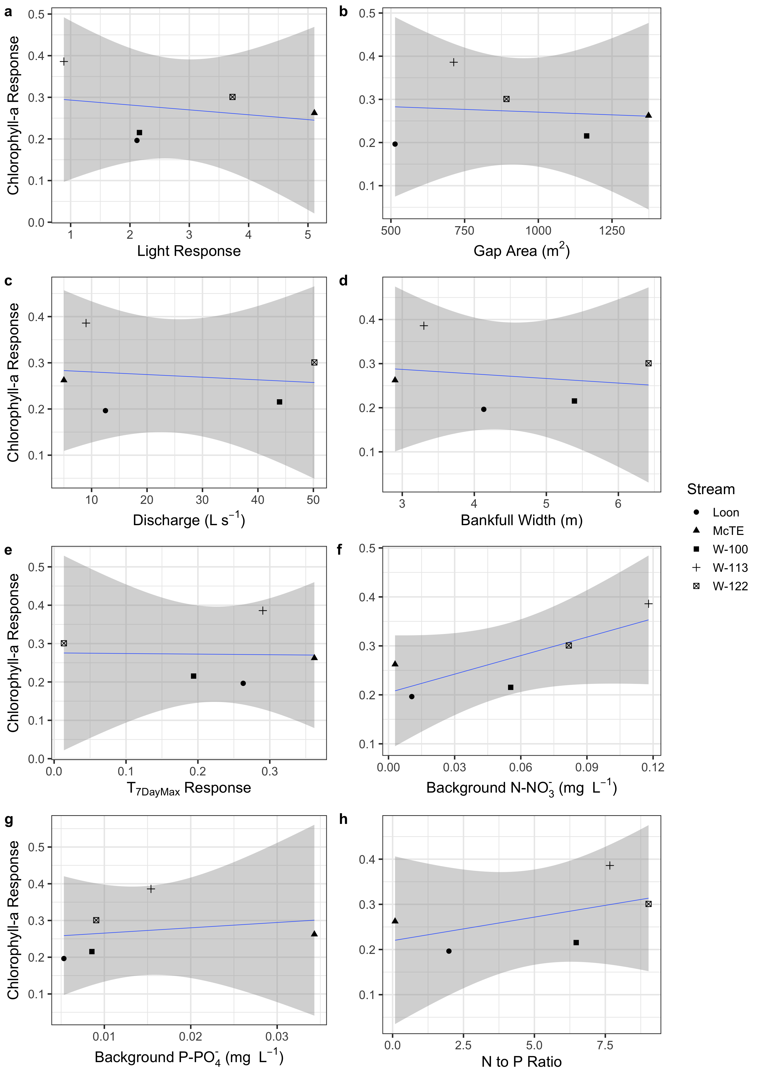

r2 = 0.279

p = 0.360

r2 = 0.040

p = 0.747

r2 = 0.650

p = 0.099

r2 = 0.050

p = 0.719

r2 = 0.001

p = 0.965

r2 = 0.065

p = 0.680

r2 = 0.026

p = 0.796

r2 = 0.013

p = 0.854

Appendix

*Additional Figures*

**Figure A.1 T7DayMean values**

Maximum 7 Day moving average mean values for each reach before and after the treatment.

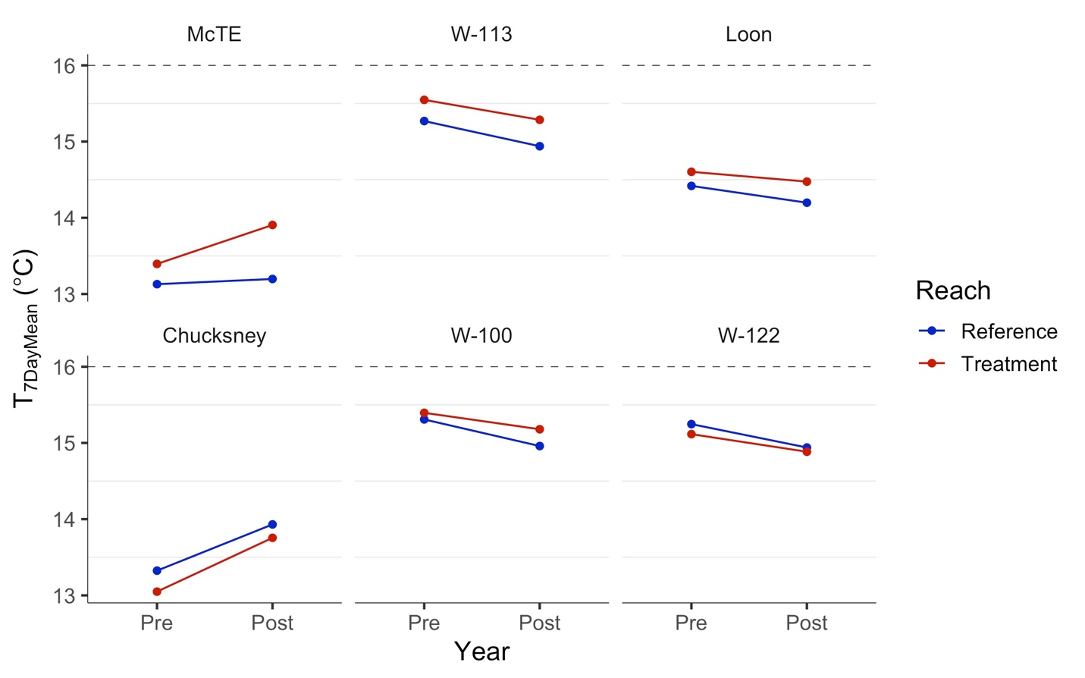

**Figure A.2 Daily mean yearly regressions**

Yearly comparisons of regression relationships for the reference reach (x-axis) versus the treatment reach (y-axis) of maximum daily downstream temperatures values and 95 percent confidence intervals (grey). Sites are ordered by stream size (bankfull width).

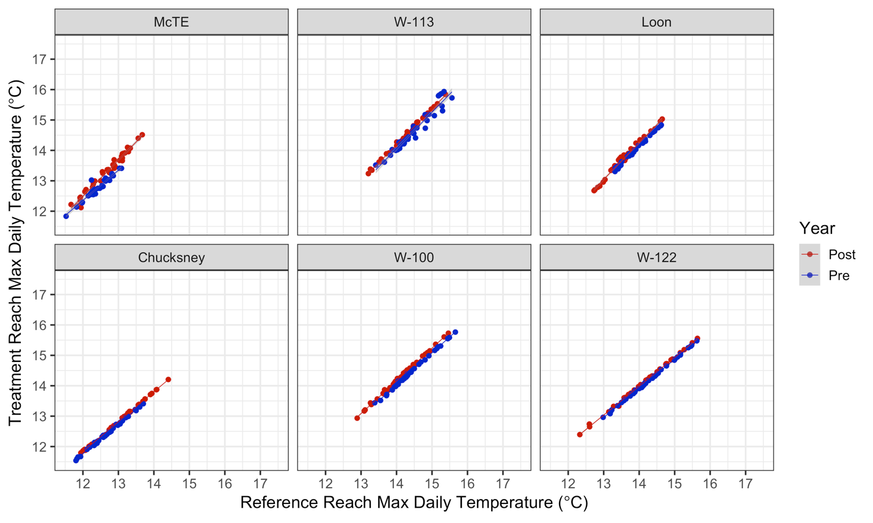

Reference Reach Mean Daily Temperature (oC)

Treatment Reach Mean Daily Temperature (oC)

*Additional Tables*

**Table A.3 BACI Statistical Analyses for T7DayMax and T7DayMean values**

Estimates, standard error, degrees of freedon, t-values, and p-values for the statistical models for T7DayMax and T7DayMean responses to the gap treatment.

T7DayMax Estimate Std.Error DF t-value p-value

Intercept 15.14 0.42 10 36.42 0.000

Year (Post) 0.02 0.16 10 0.11 0.912

Reach (Treatment) 0.17 0.27 5 0.61 0.568

BACI (Post:Treatment) 0.21 0.22 10 0.99 0.350

T7DayMean Estimate Std.Error DF t-value p-value

Intercept 14.45 0.31 10 46.06 0.000

Year (Post) -0.09 0.16 10 -0.57 0.583

Reach (Treatment) 0.07 0.25 5 0.28 0.793

BACI (Post:Treatment) 0.15 0.23 10 0.65 0.532

**Table A.4 BACI Statistical Analyses for daily maximums and daily means**

Estimates, standard error, degrees of freedon, t-values, and p-values for the statistical models for daily maximum and daily mean values.

Daily Max Value Std.Error DF t-value p-value

(Intercept) 14.409 0.461 908 31.231 0.0000

Year (Post) 0.071 0.055 908 1.254 0.2100

Reach (Treatment) 0.001 0.139 5 0.007 0.9949

BACI 0.314 0.083 908 3.775 0.0002

Daily Mean Value Std.Error DF t-value p-value

(Intercept) 13.658 0.338 908 40.399 0.0000

Year (Post) 0.028 0.050 908 0.555 0.5788

Reach (Treatment) 0.019 0.086 5 0.224 0.8313

BACI 0.166 0.073 908 2.271 0.0234

**Table A.5 Regression estimates for each site before and after the cut**

Intercept estimate, intercept standard error, slope estimate, slope standard error, r squared, and the linear fit equation for the relationship of maximum daily values in the reference versus treatment reaches each year.

|  |  |  |  |  |  |  |  |
| --- | --- | --- | --- | --- | --- | --- | --- |
| Site | Year | Intercept est. | Intercept se | Slope est. | Slope se | r2 | Equation |
| McTE | Pre | 0.9347 | 0.25 | 0.9419 | 0.02 | 0.985 | y = 0.49x + 0.93 |
| McTE | Post | -2.4970 | 0.76 | 1.2857 | 0.06 | 0.931 | y = 1.29x + -2.50 |
| W-113 | Pre | -2.5112 | 0.79 | 1.1762 | 0.05 | 0.934 | y = 1.18x + -2.51 |
| W-113 | Post | -2.9173 | 0.37 | 1.2226 | 0.02 | 0.985 | y = 1.22x + -2.92 |
| Loon | Pre | -2.1261 | 0.21 | 1.1637 | 0.01 | 0.995 | y = 1.16x + -2.13 |
| Loon | Post | -2.7635 | 0.84 | 1.2277 | 0.06 | 0.930 | y = 1.23x + -2.76 |
| Chucksney | Pre | 0.3739 | 0.20 | 0.9445 | 0.01 | 0.991 | y = 0.94x + 0.37 |
| Chucksney | Post | 0.2075 | 0.09 | 0.9668 | 0.01 | 0.998 | y = 0.97x + 0.21 |
| W-100 | Pre | -0.4898 | 0.42 | 1.0312 | 0.03 | 0.976 | y = 1.03x + -0.49 |
| W-100 | Post | -1.1872 | 0.59 | 1.0919 | 0.04 | 0.957 | y = 1.09x + -1.19 |
| W-122 | Pre | 0.8126 | 0.18 | 0.9341 | 0.01 | 0.994 | y = 0.93x + 0.81 |
| W-122 | Post | 0.2713 | 0.32 | 0.9705 | 0.02 | 0.985 | y = 0.97x + 0.27 |

**Table A.6 Fitted estimates for explanatory variables**

Slope estimates for single linear regressions of T7DayMax response.

|  |  |  |  |  |  |
| --- | --- | --- | --- | --- | --- |
| **Site Factors** | **Estimate** | **Std.Error** | **t value** | **Pr(>|t|)** |  |
| Light Response | -0.00552 | 0.0409 | -0.135 | 0.899 |  |
| Gap Size (m2) | 0.00004 | 0.0002 | 0.202 | 0.849 |  |
| Discharge (L s-1) | -0.00551 | 0.0017 | -3.273 | 0.031* |  |
| Bankful (m) | -0.08770 | 0.0124 | -7.055 | 0.002* |  |

**Table A.7** **BACI Statistical Analyses for mean PAR and mean chlorophyll *a***

Estimates, standard error, degrees of freedon, t-values, and p-values for the statistical models for mean PAR and mean Chlorophyll *a* responses to the gap treatment.

Mean PAR Value Std.Error DF t-value p-value

(Intercept) 1.079 0.192 16 5.621 0.0000

Year(Post) 0.109 0.219 16 0.497 0.6257

Reach(Treatment) -0.029 0.229 5 -0.129 0.9024

Year(Post):Reach(Treatment) 2.824 0.629 16 4.490 0.0004

Mean chlorophyll *a* Value Std.Error DF t-value p-value

(Intercept) 0.096 0.053 10 1.814 0.0997

Year(Post) 0.183 0.062 10 2.970 0.0141

Reach(Treatment) -0.008 0.062 5 -0.131 0.9007

Year(Post):Reach(Treatment) 0.256 0.087 10 2.937 0.0149